

**GREEN UNIVERSITY OF BANGLADESH**

E-Learning Management Approach (ELMA)

**Submitted by**

Md. Jaynal Abdin (191902055)

Md. Gias Uddin (191902054)

**Supervised by**

Abu Rumman Refat

Lecturer, Department of CSE

Green University of Bangladesh (PC),

Purbachal American City, Rupganj, Narayangonj.

This project submitted to the Department of Computer Science & Engineering for the partial fulfillment of the degree of Bachelor of Science in Computer Science & Engineering

# Declaration

I, we declare that this report entitled “E-learning Management Approach” is our original work and has not been submitted for assessment elsewhere. All sources of information have been acknowledged and the references cited in the report are complete and correct. This report is unique and made by us under the supervisor of Abu Rumman Refat sir, Lecturer, Department of Computer Science and Engineering, Green University of Bangladesh, for the halfway satisfaction of the prerequisite for the B.Sc. degree from the Department of Computer Science and Engineering at Green University of Bangladesh. We likewise declare that this project report is unique and has not been submitted somewhere else.

Jaynal Abdin Md Gias Uddin

ID: 191902055 ID: 191902054

# Certificate

This is to certify that the report entitled “E-learning Management Approach” is the result of an original work carried out by [Abu Rumman Refat] under my supervision. The project report has not been submitted previously in this or any other form for the award of any degree. This report has been arranged and presented by Jaynal Abdin & Gias Uddin in fulfillment of the necessity for the degree of Bachelor of Science in Computer Science and Engineering on February 20, 2023.

Abu Rumman Refat

Supervisor

Accepted and approved in partial fulfillment of the requirement for the degree Bachelor of Science in Computer Science and Engineering.

Chairman Member-2

Designation-1 Designation-2

# Acknowledgments

we first of all might want to say thanks to almighty allah for his grace which permitted us to finish this work we would like to thank thank our supervisor **Abu Rumman Refat**, Lecturer, department of computer science and engineering green university of Bangladesh, for his guidance and support throughout this project.. His ideas support persistence consideration analysis and exertion for adjustment and improvement from the start to the furthest limit of the exploration work have made the fruition of the venture conceivable. We are particularly grateful to our companions for their ethical help.

In addition, we might want to thank our department- computer science and engineering for offering us the chance for this examination work and working with us all through the entire bachelor of science program.

# Abstract

The e-learning management approach (ELMA) project aimed to design and develop a user-friendly and effective platform for delivering education online. The system was built using a variety of technologies, including HTML, CSS, JavaScript, React-JS, Next-JS and MySQL. The approach is a comprehensive solution for managing and delivering educational content to students. The system includes a variety of features and functionalities that allow educators and trainers to easily create, manage, deliver and evaluate educational content in a variety of formats. The system also includes tools for assessing student progress and providing feedback, as well as tools for communication and collaboration between students and educators.

The approach leverages the latest technological advancements to improve the delivery of educational content to learners. It incorporates four key components that are critical to successful e-learning management: course management, content management, learner management and assessment management. The approach employs various strategies and technologies such as learning management systems, data analytics, and personalized learning paths to optimize the e-learning experience for both instructors and learners. By combining traditional classroom management best practices with innovative e-learning technologies, this approach offers a comprehensive solution for managing online education programs effectively and efficiently. The approach presents a promising way to enhance the quality of e-learning programs while reducing costs and time investments.

TABLE OF CONTENTS

Declaration *. . . . . . . . . . . . . . . . . . . . . . . . . . . . . . . . .* i

Certificate *. . . . . . . . . . . . . . . . . . . . . . . . . . . . . . . . . . . .* ii

Acknowledgment*. . . . . . . . . . . . . . . . . . . . . . . . . . . . . .* iii

Abstract *. . . . . . . . . . . . . . . . . . . . . . . . . . . . . . . . . . . .* iv

List of Figures *. . . . . . . . . . . . . . . . . . . . . . . . . . . . . . . . .* x

List of Tables *. . . . . . . . . . . . . . . . . . . . . . . . . . . . . . . . .* xi

1. Introduction of The Project*. . . . . . . . . . . . . . . . . . . . . . . .* 1
   1. Introduction. . . . . . . . . . . . . . . . . . . . . . . . . . . 1
   2. Motivation . . . . . . . . . . . . . . . . . . . . . . . . . . . 2
   3. Aims and Objectives . . . . . . . . . . . . . . . . . . . . . 3
   4. Scope of the Project . . . . . . . . . . . . . . . . . . . . . 4
   5. Problem findings and feature will provide . . . . . . . . . . . . 4
   6. Research Questions. . . . . . . . . . . . . . . . . . . . . 6
   7. Project Outline . . . . . . . . . . . . . . . . . . . . . . . . 6
2. Initial Study *. . . . . . . . . . . . . . . . . . . . . . . . . . . . . . . . .* 7
   1. Introduction . . . . . . . . . . . . . . . . . . . . . . . . . . . 7
   2. Background Study . . . . . . . . . . . . . . . . . . . . . . . . 7
   3. Description of the proposed system . . . . . . . . . . . . . . . 9
   4. Feasibility Study . . . . . . . . . . . . . . . . . . . . . . . . 9
      1. Operational Feasibility . . . . . . . . . . . . . . . 9
      2. Technical Feasibility . . . . . . . . . . . . . . . 10
      3. Research and Market Analysis . . . . . . . . . . . . 10
      4. Findings of the Research and Market Analysis . . . 11
   5. Problem Areas . . . . . . . . . . . . . . . . . . . . . . . . 14
   6. Possible Solutions . . . . . . . . . . . . . . . . . . . . . . . . 15
3. Literature Review *. . . . . . . . . . . . . . . . . . . . . . . . . . . . . .* 16
   1. Discussion on the existing systems . . . . . . . . . . . . . . . 16
   2. Discussion on the Problem Solution . . . . . . . . . . . . . . . 17
   3. Comparison with the current systems . . . . . . . . . . . . 19
      1. Rokto.co . . . . . . . . . . . . . . . . . . . . . 20
      2. Hellodoctorbd.com . . . . . . . . . . . . . . . . . . 21
      3. Infoblood.org . . . . . . . . . . . . . . . . . . . . . 23
      4. Blood.ca . . . . . . . . . . . . . . . . . . . . . 24
      5. Donatebloodbd.com . . . . . . . . . . . . . . . 26
   4. Recommended Approach . . . . . . . . . . . . . . . . . . 27
4. System Requirements Analysis and Diagram Design *. . . . . . . . .* 28
   1. Introduction . . . . . . . . . . . . . . . . . . . . . . . . . . . 28
   2. Specification and Requirements . . . . . . . . . . . . . . . 28
      1. Hardware Requirements . . . . . . . . . . . . . . . 29
      2. Software Requirements . . . . . . . . . . . . . . . 29
   3. Methodology . . . . . . . . . . . . . . . . . . . . . . . . . . . 30
   4. Gantt Chart . . . . . . . . . . . . . . . . . . . . . . . . . . . 31
   5. Functional Requirements . . . . . . . . . . . . . . . . . . 31
      1. Admin . . . . . . . . . . . . . . . . . . . . . . . . 31
      2. Blood Donor . . . . . . . . . . . . . . . . . . . . . 32
      3. Blood Seekers . . . . . . . . . . . . . . . . . . 32
   6. Non-Functional Requirements . . . . . . . . . . . . . . . . . . 32
      1. Security . . . . . . . . . . . . . . . . . . . . . . . . 33
      2. Usability . . . . . . . . . . . . . . . . . . . . . 33
      3. User-friendly UI . . . . . . . . . . . . . . . . . . 33
      4. Reliable . . . . . . . . . . . . . . . . . . . . . 33
      5. Easy to Modification . . . . . . . . . . . . . . . . 33
   7. Limitations . . . . . . . . . . . . . . . . . . . . . . . . . . . 34
   8. Use Case Diagram . . . . . . . . . . . . . . . . . . . . . . . . 34
   9. DFD Model . . . . . . . . . . . . . . . . . . . . . . . . . . . 35
      1. DFD Level – 0 . . . . . . . . . . . . . . . . . . 35
      2. DFD Level - 1 . . . . . . . . . . . . . . . . . . 35
   10. Database Model . . . . . . . . . . . . . . . . . . . . . . . . 36
5. System Interface Design and Implementation *. . . . . . . . . . . . . . .* 38
   1. Introduction . . . . . . . . . . . . . . . . . . . . . . . . . . . 38
   2. Design Process . . . . . . . . . . . . . . . . . . . . . . . . 38
   3. Frontend Development . . . . . . . . . . . . . . . . . . . . . 39
   4. Backend Development . . . . . . . . . . . . . . . . . . . . . 39
   5. System Designs . . . . . . . . . . . . . . . . . . . . . . . . 39
      1. Home Page . . . . . . . . . . . . . . . . . . . . . 39
      2. About Us . . . . . . . . . . . . . . . . . . . . . 40
      3. Blood Request . . . . . . . . . . . . . . . . . . 40
      4. Search Donor . . . . . . . . . . . . . . . . . . . . . 41
      5. Donor Registration . . . . . . . . . . . . . . . . . . 42
      6. Blog . . . . . . . . . . . . . . . . . . . . . . . . 43
      7. Contact Us . . . . . . . . . . . . . . . . . . . . . 44
      8. Login Page . . . . . . . . . . . . . . . . . . . . . 44
      9. Password Reset . . . . . . . . . . . . . . . . . . 45
      10. Donor Dashboard . . . . . . . . . . . . . . . . . . 45
      11. Add Donation . . . . . . . . . . . . . . . . . . . . . 45
      12. Donation History . . . . . . . . . . . . . . . . . . 46
      13. Blood Request . . . . . . . . . . . . . . . . . . 46
      14. Profile . . . . . . . . . . . . . . . . . . . . . . . . 47
      15. Admin Dashboard . . . . . . . . . . . . . . . . . . 47
      16. Setup . . . . . . . . . . . . . . . . . . . . . . . . 48
      17. Manage Donors . . . . . . . . . . . . . . . . . . 50
      18. Blog . . . . . . . . . . . . . . . . . . . . . . . . . . 51
      19. Profile . . . . . . . . . . . . . . . . . . . . . . . . . 51
      20. Blood Request . . . . . . . . . . . . . . . . . . . . 52
6. Test Case *. . . . . . . . . . . . . . . . . . . . . . . . . . . . . . . . . .* 53
   1. Introduction . . . . . . . . . . . . . . . . . . . . . . . . . . . 53
   2. Test Case Summary . . . . . . . . . . . . . . . . . . . . . . . 53
   3. Test Cases . . . . . . . . . . . . . . . . . . . . . . . . . . . . 53
7. Conclusion and Future Work *. . . . . . . . . . . . . . . . . . . . . . .* 68
   1. Summary . . . . . . . . . . . . . . . . . . . . . . . . . . . . . 68
   2. Future Work of the System . . . . . . . . . . . . . . . . . . . 68
   3. Value of This Project . . . . . . . . . . . . . . . . . . . . . . 69

Reference *. . . . . . . . . . . . . . . . . . . . . . . . . . . . . . . . . . . .* 71

List of Figures

|  |  |  |
| --- | --- | --- |
| 2.1 | Gender of blood seekers (a) and seekers’ relation with patients (b) . . | 12 |
| 2.2 | Gender of blood donors (a) and donors’ relation with patients (b) . . . | 12 |
| 2.3 | Blood needed in different medical purposes . . . . . . . . . . . . . . | 13 |
| 2.4 | Bags of blood needed in every case (a) and time needed to manage |  |
|  | per bag blood (b) . . . . . . . . . . . . . . . . . . . . . . . . . . . | 14 |
| 3.1 | The overview of the Rokto.co . . . . . . . . . . . . . . . . . . . . . | 20 |
| 3.2 | The overview of the Hellodoctorbd.com . . . . . . . . . . . . . . . | 22 |
| 3.3 | The overview of infoblood.org . . . . . . . . . . . . . . . . . . . . . | 23 |
| 3.4 | The overview of the Blood.ca . . . . . . . . . . . . . . . . . . . . . | 25 |
| 3.5 | The overview of the Donatebloodbd.com . . . . . . . . . . . . . . . . | 26 |
| 4.1 | Agile Methodology . . . . . . . . . . . . . . . . . . . . . . . . . . . | 30 |
| 4.2 | Gantt Chart . . . . . . . . . . . . . . . . . . . . . . . . . . . . . . . | 31 |
| 4.3 | Use Case Diagram . . . . . . . . . . . . . . . . . . . . . . . . . . . | 34 |
| 4.4 | DFD Model Level - 0 . . . . . . . . . . . . . . . . . . . . . . . . . . | 35 |
| 4.5 | DFD Model Level - 1 . . . . . . . . . . . . . . . . . . . . . . . . . . | 36 |
| 4.6 | Database Model Design . . . . . . . . . . . . . . . . . . . . . . . . . | 37 |
| 5.1 | Home Page . . . . . . . . . . . . . . . . . . . . . . . . . . . . . . . | 40 |
| 5.2 | About Us Page . . . . . . . . . . . . . . . . . . . . . . . . . . . . . | 40 |
| 5.3 | Blood Request Page . . . . . . . . . . . . . . . . . . . . . . . . . . . | 41 |
| 5.4 | Search Donor Page . . . . . . . . . . . . . . . . . . . . . . . . . . . | 42 |
| 5.5 | Donor Registration (OTP Page) . . . . . . . . . . . . . . . . . . . . . | 42 |

|  |  |
| --- | --- |
| 5.6 Donor Registration (Information Page) . . . . . . . . . . . . . . . . . | 43 |
| 5.7 Blog Page . . . . . . . . . . . . . . . . . . . . . . . . . . . . . . . . | 43 |
| 5.8 Contact Us Page . . . . . . . . . . . . . . . . . . . . . . . . . . . . . | 44 |
| 5.9 Login Page . . . . . . . . . . . . . . . . . . . . . . . . . . . . . . . | 44 |
| 5.10 Password Reset Page . . . . . . . . . . . . . . . . . . . . . . . . . . | 45 |
| 5.11 Donor Dashboard Page . . . . . . . . . . . . . . . . . . . . . . . . . | 45 |
| 5.12 Add Blood Donation Page . . . . . . . . . . . . . . . . . . . . . . . | 46 |
| 5.13 Donation History Page . . . . . . . . . . . . . . . . . . . . . . . . . | 46 |
| 5.14 See Blood Request Page . . . . . . . . . . . . . . . . . . . . . . . . | 47 |
| 5.15 Donor Profile Page . . . . . . . . . . . . . . . . . . . . . . . . . . . | 47 |
| 5.16 Admin Dashboard Page . . . . . . . . . . . . . . . . . . . . . . . . . | 48 |
| 5.17 Blood Group Setup . . . . . . . . . . . . . . . . . . . . . . . . . . . | 48 |
| 5.18 Division Setup . . . . . . . . . . . . . . . . . . . . . . . . . . . . . . | 49 |
| 5.19 Districts Setup . . . . . . . . . . . . . . . . . . . . . . . . . . . . . . | 49 |
| 5.20 Upazila Setup . . . . . . . . . . . . . . . . . . . . . . . . . . . . . . | 50 |
| 5.21 Donor Management . . . . . . . . . . . . . . . . . . . . . . . . . . . | 50 |
| 5.22 Add Blog . . . . . . . . . . . . . . . . . . . . . . . . . . . . . . . . | 51 |
| 5.23 Blog List . . . . . . . . . . . . . . . . . . . . . . . . . . . . . . . . | 51 |
| 5.24 Admin Profile Page . . . . . . . . . . . . . . . . . . . . . . . . . . . | 52 |
| 5.25 Blood Request Page . . . . . . . . . . . . . . . . . . . . . . . . . . . | 52 |

List of Tables

|  |  |
| --- | --- |
| 6.1 Registration . . . . . . . . . . . . . . . . . . . . . . . . . . . . . . . | 54 |
| 6.2 Login . . . . . . . . . . . . . . . . . . . . . . . . . . . . . . . . . . | 55 |
| 6.3 Blood Request . . . . . . . . . . . . . . . . . . . . . . . . . . . . . . | 56 |
| 6.4 Donor Searching . . . . . . . . . . . . . . . . . . . . . . . . . . . . | 57 |
| 6.5 Blog . . . . . . . . . . . . . . . . . . . . . . . . . . . . . . . . . . . | 58 |
| 6.6 Contact Us . . . . . . . . . . . . . . . . . . . . . . . . . . . . . . . . | 59 |
| 6.7 Donor Panel . . . . . . . . . . . . . . . . . . . . . . . . . . . . . . . | 60 |
| 6.8 Admin Panel . . . . . . . . . . . . . . . . . . . . . . . . . . . . . . . | 64 |

Chapter 1

Introduction of the Project

## Introduction

1. The e-learning management system (LMS) is a web-based platform that allows educators to create and manage online courses, track student progress, and deliver content. The project was initiated to address the need for a more efficient and effective way to deliver education to a diverse student population. The LMS is intended to be user-friendly and intuitive, with a focus on ease of use and accessibility. The system is also highly customizable, allowing educators to tailor their courses to their specific needs and the needs of their students.

The increasing popularity of online education has led to the development of various e-learning management systems. These systems are designed to facilitate online learning by providing tools and resources for students, teachers, and administrators. The goal of this project was to develop an e-learning management system that addresses the needs of students, teachers, and administrators and enhances the online learning experience.

## E- Learning management approach is a web application for the administration, documentation, tracking, reporting, and delivery of electronic educational technology.

* + A flexible learning solution that you can set up whether for self-paced learning or synchronous learning
  + This project has three panel: Such as 1. Admin panel 2. Instructor panel and 3. Student panel.

## 1.2 Motivation

With the rise of technology and increasing demands for flexible and accessible learning, e-learning has become a crucial tool for educational institutions, businesses, and individuals. E-learning provides learners with the opportunity to access courses and resources from anywhere, at any time, making it a more efficient and effective method of learning. In order to ensure the success of e-learning programs, a comprehensive e-learning management approach is needed to provide learners with the necessary tools, resources, and support

## **To Simplify learning process**

* **All types of online based teaching learning tools still now stay in random or unorganized. That’s why user face difficulty.**
* **Want to make a combined and easier online base teaching learning for the users**
* **A cloud-based software package that enables enterprises to deliver learning content and resources to the users.**

## 1.3 Aims and Objectives

Aims:

The aim of this project is to design, develop, and evaluate an e-learning management approach that provides learners with a comprehensive and engaging learning experience.

Making easy and efficient online based education platform for all in every situation.

Objectives: The objectives of the project are to:

1. Improve accessibility and flexibility

2. Enhance engagement and motivation

3. Monitor learner progress

4. Offer support and assistance

5. Continuously evaluate and improve

**Improve accessibility and flexibility:** The e-learning management approach aims to provide learners with the ability to access courses and resources at their convenience, from anywhere with an internet connection.

**Enhance engagement and motivation:** By implementing engaging and interactive e-learning strategies, learners will be more motivated to participate in courses and complete them successfully.

**Monitor learner progress:** The e-learning management approach will include monitoring learner progress and providing feedback, so learners can better understand their strengths and weaknesses and improve their learning outcomes.

**Offer support and assistance:** Learners will have access to support and assistance throughout their e-learning journey, including technical support, instructor feedback, and peer support.

**Continuously evaluate and improve:** The e-learning management approach will be regularly evaluated and improved based on learner feedback, so that it can continuously provide the best learning experience for all learners.

By implementing this e-learning management approach, learners will be able to access high-quality courses and resources, and receive the support and assistance they need to achieve their learning goals. This will ultimately result in more engaged and motivated learners, higher completion rates, and more successful learning outcomes.

To provide an efficient and flexible platform for delivering educational content

To improve the overall educational experience for students

To provide tools for assessing student progress and providing feedback

To facilitate communication and collaboration between students and educators

## 1.4 Scope of the Project

The e-learning management approach will cover all aspects of managing e-learning programs, including the design, development, delivery, and evaluation of online courses and resources. It will be scalable and adaptable and suitable for both synchronous and asynchronous learning. It will cover the management of learners and instructors, including enrolment, communication, progress tracking, and feedback. It will provide learners with access to technical support and assistance, as well as opportunities for peer interaction and collaboration.

The scope of the project are including the following features:

Course creation and management

Content delivery and management

Online meeting creation and management

Student personal notes creation and management

Student progress monitoring

Assessment and feedback tools

Communication and collaboration tools

User management and authentication

User-friendly and responsive interface

## 1.5 Problem findings and feature will provide

Problem Findings:

The problem findings identified the challenges that learners face in e-learning, including access to resources, engagement, monitoring, support, and evaluation. These challenges can result in low completion rates, poor learning outcomes, and a negative learning experience.

Features:

The e-learning management approach will include features such as a user-friendly interface, multimedia resources, assessments, collaboration tools, progress tracking, and feedback. It will provide learners with access to technical support and assistance, as well as opportunities for peer interaction and collaboration. It will be scalable and adaptable and suitable for both synchronous and asynchronous learning.

## 1.6 Research Questions

The question depends on a comprehension of the users’ origination’s, feelings, and contemplation’s. Moreover, the mission and vision explanation give the audience an exceptionally clear feeling of what’s on their brains. Here are the questions, which should be replied in a consistent order.

Research Question 1: What are the benefits of e-learning management approach over traditional classroom teaching?

Answer: E-learning management approach has various advantages over traditional classroom teaching. It provides flexibility, convenience, personalized learning, and cost-effectiveness. E-learning allows students to learn at their own pace, and it provides access to a vast range of resources that are not available in traditional classroom settings. Moreover, e-learning can be easily accessed from anywhere in the world with an internet connection. Hence, e-learning management approach is considered an effective and efficient way of delivering education.

Research Question 2: Why will people use this e-learning management approach?

1. Flexibility: E-learning management approach allows learners to access course materials and participate in learning activities at their own pace and from any location, providing a high degree of flexibility and convenience.
2. Personalized learning: E-learning management approach can be designed to provide a personalized learning experience, adapting to learners' individual needs, preferences, and learning styles.
3. Cost-effectiveness: E-learning management approach can be more cost-effective than traditional classroom-based learning, as it eliminates the need for physical facilities and travel expenses.
4. Access to resources: E-learning management approach can provide access to a wide range of resources and learning materials, including videos, simulations, and interactive multimedia, which may not be available in traditional classroom-based learning.
5. Efficient time management: E-learning management approach allows learners to manage their time more effectively, enabling them to study at their own pace and balance their learning with other commitments such as work, family, or other interests.

Research Question 3: What are the challenges that learners face in e-learning?

Answer: There are several challenges that learners may face in e-learning, including:

1. Technical difficulties: Technical difficulties, such as slow internet speed, outdated software, or hardware malfunctions can hamper the learning experience.
2. Limited interaction and engagement: E-learning can be isolating for learners, as they may not have the opportunity to interact and engage with peers and instructors.
3. Self-discipline and motivation: E-learning requires learners to be self-motivated and disciplined to stay on track with their studies, which can be challenging for some individuals.
4. Limited access to support: Learners may have limited access to support services, such as tutors, counselors, and advisors, which can make it difficult for them to get help when they need it.
5. Lack of social interaction: Learners may miss out on the social interactions and networking opportunities that are available in a traditional classroom setting.

## 1.7 Project Outline

* Chapter- 2: Initial Study
* Chapter- 3: Literature Review

Chapter 4:System Requirements Analysis and Diagram Design

Chapter 5:System Interface Design and Implementation

Chapter 6:Test Case

Chapter 7:Conclusion and Future Work

Chapter 2

Initial Study

## 2.1 Introduction

Blood is one of the main components of human body, it tends to be characterized as liquid in the body that convey oxygen from lungs to the rest part of the body. We have 4 to 6 liters of blood in our grown-up body rely upon size. This framework is proposed to find the closest blood donor in instances of crises and in quickest way. This exploration additionally is take care of the blood the executives’ concern where the blood can’t be save for quite a while and cause blood donation center require blood whenever.

GEO-Location based blood donor searching System is meant to develop an Internet based solution for search blood donor all over the country. It is exceptionally normal situation that many individuals dies because of not getting blood in crisis time. This project is expected to give a protected and fast method for tracking down a blood donor and give blood. This system will be formed into a framework that will help the blood donation centers, intentional associations, blood givers and patients to effortlessly team up and do free blood donation.

## 2.2 Background Study

Right now the world relies upon technology and everybody from the youthful to the old appear to be profoundly involved. Because of the fast improvement of technology, it assume a huge part in the cutting edge life of individuals and it significant components in the present society. One of the ongoing technology is GEO location. A GEO location based system is a deeply grounded technology in this period which is solid innovation. It distinguishes the ongoing geolocation of an objective. Utilizing GPS empowered smartphones to gather route information is moderately new advancements, however quickly propelling method utilized in research. Blood donation is one of the most commitments towards the general public. Millions of individuals need blood transfusions every year. Some might require blood during a medical surgery. Others rely upon it after an accident or on the grounds that they have a sickness that requires blood parts.As per World Health Organization (WHO), expressed that to full filled the blood interest, 4.6% out of the populace ought to approach as a donor yet just 2.25% who selflessly be as a donor.

However there are numerous voluntary associations and groups are working in our country to serve blood at whatever point get blood demand. There are some web-based blood donor searching through entries additionally which are predominantly founded on the fundamental hunt framework on ABO blood gathering like http://infoblood.org/ which provide the users to look through the particular donor no location based searching, https://badhan.org/ permits district wise donor searching, http://www.bdrcs.org/ donate-blood red Crescent blood donation society has a little data set with no search choice and finally, http://www.blooddonorsbd.com/ has the blood group wise and region wise donor searching.

Yet, there is no concentrated GPS based blood donor searching system in our country. Presently it is basically impossible to legitimize whether a donor is sufficiently fit to give blood or on the other hand in the event that a donor is giving blood after least 120 days of past donation. Additionally, it is absolutely impossible to give automatic notify the close by accessible blood donors about a crisis blood donation demand. Voluntary associations and volunteers generally attempt to deal with the necessary blood which may at times cause death for getting late. Our system will make the entire interaction all the more simple, solid and viable and furthermore guarantee the wellbeing of donor’s medical problems. Thus, this kind of system has a sound demand in current market.

## 2.3 Description of the proposed system

GEO-Location Based Blood Donor Searching System is a web-based application that assists with finding the current location of the blood donor. Utilizing this system, individuals can look and demand for blood donors in their closest area, blood donors can see notification and blood requests and furthermore see their donation history, system can legitimize the donor’s eligibility to give blood, deal with donor’s serology reports and add the last donation subtleties of the donor.

GEO-Location Based Blood Donor Searching System is a web-based application that assists with finding the current location of the blood donor. Utilizing this system, individuals can look and demand for blood donors in their closest area, blood donors can see notification and blood requests and furthermore see their donation history, system can legitimize the donor’s eligibility to give blood, deal with donor’s serology reports and add the last donation subtleties of the donor.

Moreover, individual blood Donor can manage their profile. As like they can change their own information, contact number, area, add donation history, etc. Thus, patients can search and find blood donor effectively by using our application.

## 2.4 Feasibility Study

In General, Feasibility study is an evaluation of the practical usability of a proposed project plan or technique. This is finished by dissecting some feasibility factors.

### 2.4.1 Operational Feasibility

Since, this feasibility worry about the convenience, usability and required functionalities of the proposed system. The proposed GEO-Location Based Blood Donor Searching System has appropriate validation and verification for user’s inputs, exceptionally simple and smooth route system, and location based searching through user’s choice, simple request option which will make the system a lot more straightforward and easy to utilize. System Administrator, blood donor and blood searcher can undoubtedly gain admittance to the entrance with legitimate credentials and play out their assignments productively.

### 2.4.2 Technical Feasibility

This feasibility test chides, the users of GEO-Location Based Blood Donor Searching System can undoubtedly deal with their activities as opposed to past manual interaction. We are going to use IIS for deployment, MSSQL database server, Asp.Net Core utilizing entity framework, Microsoft office for documentation reason. The system is planned and created utilizing most recent and famous web technologies that ensures that the system is viable to run in any internet browsers with low-level Internet connection. Our system has an entrance control order to keep up with secure admittance to the system information. Web based application is stage autonomous and its picked advancement stage and assets are reasonable and cost effective so it will be technically

feasible.

### 2.4.3 Research and Market Analysis

This segment incorporates the market and user’s interest along with the ratio of seekers and donations. In Bangladesh, most maternal death happens because of the absence of blood in crisis situations. As per WHO (World Health Organization), just 40% of required blood is gathered every year in Bangladesh and 80% of women who die during pregnancy, bite the dust for blood (WHO, 2017). Then again, street accidents, fire, and risky heart diseases are common scenarios in our nation and this large number of cases require an enormous measure of blood for the victims.

A survey has been led by ”Access to Information (a2i), ICT Division, Bangladesh” to figure out issues in getting blood donors in Bangladesh. Information has been gathered from 430 respondents in various metropolitan and country areas of Bangladesh. Besides, top to bottom meetings have been led by medical clinic authorities, blood donating associations, public and private associations, and volunteers who work for different blood donating associations.

This study discovers that patients need blood for delivery cases (76%), medical surgery (55%), kidney diseases (33%), thalassemia (37%), and sickliness (41%). Around 48% of blood seekers report that they expect around 19-24 hours for dealing with each bag of blood. The seekers additionally report that they gather blood from family members (77%), blood donating associations (33%), and blood donation centers (26%). Around 26% of donor’s report that they need to pass in excess of 6 km for blood donation. Previously and during blood donation, donors faced a few issues like transportation issues (38%), adapting to crisis cases (32%), incompetent staff (29%), health-related issues (15%), and extended cross-checking process (35%).

There are various individuals who desperately wanted to donate blood, but can’t find the confidence because of these problems. In any case, they can’t donate blood because of the absence of accessible communication with blood seekers. Keeping up the database of donors, preparing staff, and involving the latest technologies and machines for blood donor searching and blood donation process can remove this kind of problem in donor searching as well as donation.

In the current era, there is colossal demand for the GPS system and automated systems for managing the blood donor searching and donation. This system can automatically send messages emails notifications to the important blood donors after a blood request is created. Thus, the “GEO-Location Based Blood Donor Searching System” will be a new and compelling stage for the people of the country.

### 2.4.4 Findings of the Research and Market Analysis

Findings from Blood Seekers and Blood Donors:

Blood Seekers:

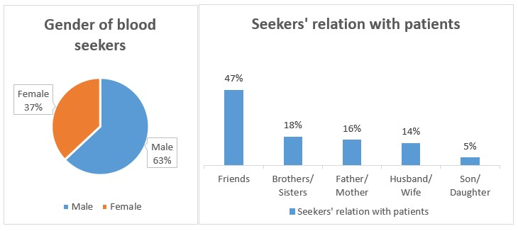

Figure 2.1: Gender of blood seekers (a) and seekers’ relation with patients (b)

Figure 2.1 (a) represents the gender of the blood searchers. It has been observed that there were 63% of male blood searchers what’s more, 37% of female blood searchers searched for blood for their family members and companions.

Figure 2.1 (b) represents blood searchers’ connection with the patients for whom blood was searched and gathered. It has been found that around 47% of respondents searched for blood for their friends. Around 18% of respondents have searched for blood for their siblings while 16% of blood searchers searched for blood for their dad and mom Blood Donors:

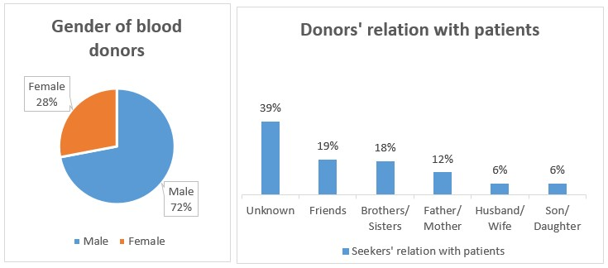

Figure 2.2: Gender of blood donors (a) and donors’ relation with patients (b) Figure-2.2 (a) represents the gender of the blood donors. There were 72% male donors and 28% are female.

Figure-2.2 (b) represents the donors’ connection with the patients. It has been tracked down that around 39% respondents given blood to unknown patients. Around 19% donors have given blood to their friends. Around 18% donors have given blood to their

siblings.

Purposes of Blood:

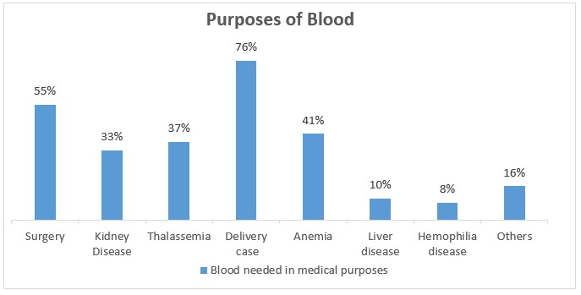

Figure 2.3: Blood needed in different medical purposes

Figure-2.3 shows the reasons or instances of blood donation. It has been observed that blood is required in the vast majority of the delivery cases (76%). Around 55% respondents have referenced that they gave blood to a medical surgery patients. Around 41% donors have referenced to need blood for Anemia patients. Approximately 37% of Thalassemia patients looking for blood. 33% Kidney Disease seekers are looking for donors.10% and 8% patients of Liver disease and Hemophilia disease respectively desperate for blood and around 16% other patients looking for blood donation.

Needs of Blood Bag and Time:

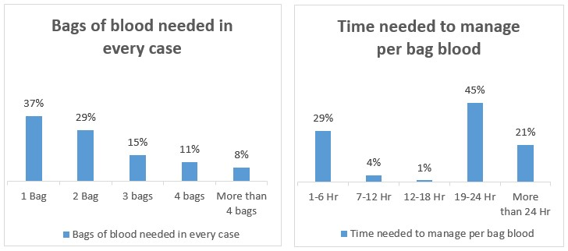

Figure 2.4: Bags of blood needed in every case (a) and time needed to manage per bag blood (b)

From figure 2.4 (a) it has been tracked down that a greater part (37%) of respondents required one bag of blood. Then again, just 8% of respondents believed that they required multiple bags of blood. Around 29% of respondents have referenced that they required two bags of blood. 15% of respondents demand 3 bags and 4 bags of blood needed for around 11% of patients.

Figure 2.4 (b) addresses the time required by the blood searchers to gather a bag of blood. A larger part (45%) of the respondents have referenced that they expected 19-24 hours to manage each bag of blood. Just 1% has announced that they required 12-18 hours to gather for each bag blood. Around 29% responded that need 1-6 hours to collect every bag of blood. 4% claimed that they needed 7-12 hours and 21% opine that they needed more than 24 hours to collect each bag of blood.

## 2.5 Problem Areas

It is a significant issue that the lack of blood in crisis circumstances like surgery and pregnancy issue. As indicated by World Health Organization (WHO) just 31% of requested blood comes from the voluntary donors. But the patients can not get the donors within short time because of they can not find the donors in their nearest location as well as don’t get the direct contact information of donors. As a result the patient fallen into life risk and sometimes died. Another problem for donor that they can not take record of their last blood donation history. So that they don’t know whether they are eligible to donate or not. Sometimes donor donate blood inside of 120 days period of last donation. It make a huge health issues for the donors.

## 2.6 Possible Solutions

It is actually quite complex process and the users faces a huge amount of problems. The solution is to make a system based on GPS. This system should centrally store the all database of blood donors, blood seekers. Particular location wise and donor eligibility wise blood donor searching technology should be implemented into the system. Automatic donor filtering, eligibility checking, valid blood request checking, give notification to donor by the email and mobile SMS in every blood request. Take the donation history of donor and notify them after 120 days from last donation. These all can be deployed via a web-based application system and use the latest GPS technology to find out the nearest donors within short time.

We think this system can be reduced the problem which we mention above and can save the valuable life of patients as well as maintain a sound health of all donors.

Chapter 3

Literature Review

E-learning management approach typically involves the use of a learning management system (LMS) to manage and deliver course content, assignments, assessments, and other learning activities. The LMS provides a centralized platform for learners to access course materials, participate in discussions, collaborate with peers, and receive feedback from instructors. The e-learning management approach can be designed to provide a personalized learning experience, adapting to learners' individual needs, preferences, and learning styles.

Effectiveness of E-learning Management Approach:

Several studies have investigated the effectiveness of e-learning management approach in promoting effective learning and enhancing the overall learning experience. For example, a study by Hwang and Wang (2018) found that e-learning management approach was effective in improving students' knowledge and skills, and promoting self-regulated learning. Similarly, a study by Gao and Sun (2018) found that e-learning management approach was effective in promoting collaborative learning and enhancing the engagement and motivation of learners.

Factors Influencing the Success of E-learning Management Approach:

Several factors can influence the success or failure of e-learning management approach. For example, the design and quality of course materials, the level of interactivity and engagement, the level of instructor support, the level of learner autonomy and motivation, and the level of technical support and accessibility. A study by Johnson and Aragon (2003) found that learners' satisfaction with e-learning management approach was influenced by factors such as course design, level of interactivity, and quality of instructor support.

Benefits and Drawbacks of E-learning Management Approach:

E-learning management approach offers several benefits, including flexibility, personalized learning, cost-effectiveness, access to resources, efficient time management, consistent quality, and collaborative learning. However, there are also some drawbacks, including the lack of face-to-face interaction, the potential for technical difficulties, the lack of socialization and community building, and the potential for isolation and disengagement. A study by Means et al. (2013) found that e-learning management approach can be as effective as traditional classroom-based learning, but may require a different set of skills and strategies for both learners and instructors.

## 3.1 Discussion on the existing systems

GEO-Location Based Blood Donor Searching System is mainly focusing on the donor searching system and Management Information System (MIS). After the public authority of Bangladesh re-shaped the Bangladesh Council of Blood Transfusion in 2009, a few associations created sites for blood donor searching. Like rokto.co, hellodoctorbd, bloodseek.com, INFOBLOOD, Blood Donors Club Bangladesh, Blood Cell, BADHON, and Bangladesh Red Crescent Society. Yet at the same time now there is no completed system for the blood donor searching and blood donation system in the country. Every one of the above associations implements its system simply by thinking about its organizational activities. However, the main issue is there is no coordinated effort among these associations and their activities, because of the absence of proper analysis and the latest technology.

The main issues related to the current system of our country are:

* Not having any centralized system.
* Not having a particular location-based donor searching system.
* Not having the latest technology like GPS
* Not have donor’s full information, blood donation tracking system.
* Not having the donor verification and eligibility filtering system.
* Not having donor’s donation history storing system.
* Not having legitimate regulation and strategy.

## 3.2 Discussion on the Problem Solution

GEO-Location Based Blood Donor Searching System project is about the unified blood donor searching and safe blood donation system which is under well-being and clinical domain. In this time of innovation and globalization automation is wherever from the bed to the workplace. The medical area isn’t on the back foot. Technology makes changes consistently in this area. Everything is getting computer based and informationdriven. The proposed system solution ought to consider the issues expressed below:

* Security

Since the system needs to store very confidential information including individual information, information security ought to be the number 1 thought for the proposed system solution. The system ought to execute high-security elements and carry out role-based limited admittance to the information.

* Trust

The issue generally looked at by this sort of system is reliability. The whole system ought to be straightforward to its users. To procure trust from the users the public authority strategy ought to integrate.

* Privacy

Privacy of the blood donor and searcher needs to guarantee. To guarantee security the proposed system ought to utilize encrypted information transfer and furthermore utilize a scrambled VPN tunnel for client-server reaction.

* Security

Since the system needs to store very confidential information including individual information, information security ought to be the number 1 thought for the proposed system solution. The system ought to execute high-security elements and carry out role-based limited admittance to the information.

* Remote Access

As the GEO-Location Based Blood Donor Searching System is hosted on the Internet and various users’ access it through the Internet the entrance ought to be checked and safeguarded. Network Address Server, External Firewall and VPN ought to be utilized to guarantee safe remote access.

* Users Identity Verification

Individuals give fraud information on the Internet because of less reliable. To guarantee the Identity of the blood donor they ought to give a distinguishing proof material like NID. As the system administrator can confirm the identity by questioning to important power.

* Server Down or all day, every day Availability

The accessibility of the application all the time from everywhere in the nation ought to be thought of. Since there is no alternative option so the application must accessible 24/7. Server down, low data transmission, and mass traffic need to deal with.

* Data Backup

The proposed system works with an enormous measure of data so it necessities to guarantee ordinary backup of this information. A proxy server and information storage ought to be continuously saved and prepared for backing up the GEOLocation Based Blood Donor Searching System.

* Train data-set
* Searching

## 3.3 Comparison with the current systems

Encompassing is changing throughout time and time carries new technologies to get updated and make life more straightforward to live. Presently days the world is actually too little like a town in view of the Internet. There are great many systems for taking care of similar issues in various ways. However, GEO-Location Based Blood Donor Searching System is a special solution yet there are a few existing systems working in a similar space.

Here in this segment, we are going to think about the well famous and well-known current sites and rundown their best-highlighted features, assets, and shortcomings. These are-

* https://www.rokto.co/ (Bangladesh)
* http://hellodoctorbd.com/blood-donor (Bangladesh)
* http://infoblood.org/ (Bangladesh)
* https://blood.ca/en (Canada)
* https://www.donatebloodbd.com/ (Bangladesh)

### 3.3.1 Rokto.co

Rokto.co is a famous blood donor searching system in Bangladesh. This application allows users to search a donor or become a blood donor as well. Having mention that Rokto is always free for everyone. About 5322 donors are registered into this system and they are giving service to 64 districts.

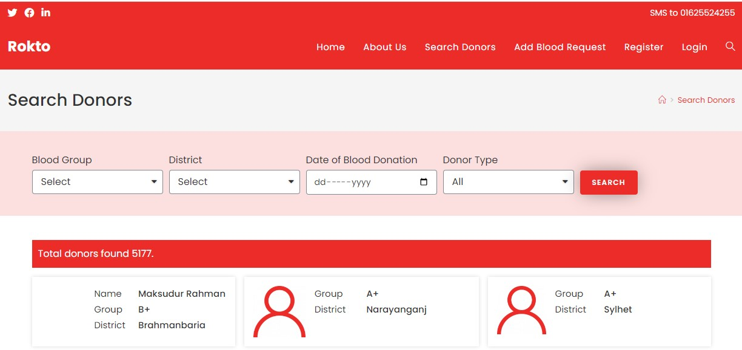

Figure 3.1: The overview of the Rokto.co

Best Features

* Blood donor searching based on blood group and static location wise.
* Maintaining the user’s personal profile.
* Send person to person request.
* Send blood request to system admin.

Limitations

* Do not have any option to direct contact with donor.
* Blood seekers have to registration when need add a blood request.
* No real-time request processing or notification system.
* No GPS technology has been implemented.
* Do not have notify the donor when they are eligible to donate blood.

### 3.3.2 Hellodoctorbd.com

Hello Doctor is the boundless program pointed toward advancing Bangladesh’s cutting edge in medical care. Hello Doctor is supported with the most trusted, exact, and modern medication and medical services information hotspot for the overall population and patients from the place of Hello Doctor BD. This application is committed to assisting you with viewing complete and detailed data about Medicines, Diseases, Health Tips, Doctor and Hospital Directory, Doctor’s Finder, Medicine Reminder, Medicine Cost Calculator, and a lot more at the simplicity of your fingertips.

Along with this services, Hello Doctor providing a dedicate blood donor searching system. This system is also free for every users.

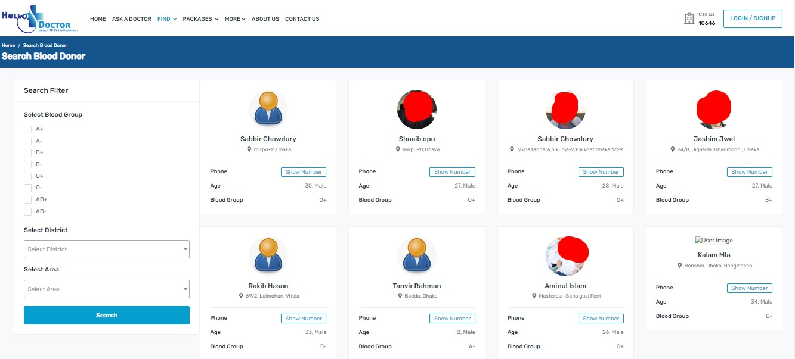

Figure 3.2: The overview of the Hellodoctorbd.com

Best Features

* Blood donor searching based on blood group & static location wise.
* Maintaining the user’s personal profile.
* Send person to person request.
* Direct contact with donors

Limitations

* No real-time request processing or notification system.
* Do not have any facility to whether the donor is eligible or not.
* No GPS technology has been implemented.
* Do not have notify the donor when they are eligible to donate blood.
* Not only for blood services.

### 3.3.3 Infoblood.org

Infoblood.org is the biggest blood searching system in Bangladesh. The site permits its users to look as blood donors or to turn into a blood donors. It additionally works with the different associations to get enlisted and utilize this site for their exercises. Almost 35449 donors registered into this system.

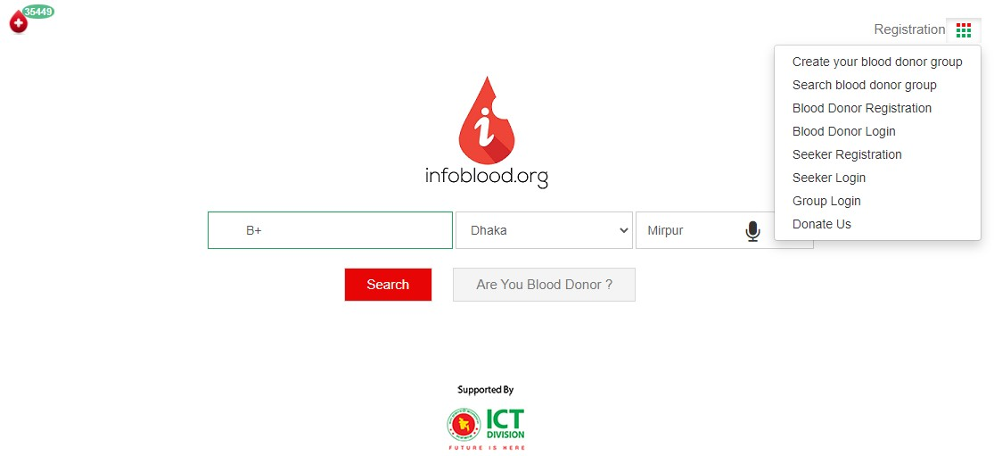

Figure 3.3: The overview of infoblood.org

Best Features

* Blood donor searching based on blood group & static location wise.
* Maintaining the user’s personal profile.
* Send person to person request.
* Create blood donor group.

Limitations

* No real-time request processing or notification system.
* Do not have any facility to whether the donor is eligible or not.
* No GPS technology has been implemented.
* Do not have notify the donor when they are eligible to donate blood.
* Lack of data privacy and security.
* No identity verification for users.
* Blood seekers have to registration when need send a blood request to donors.

### 3.3.4 Blood.ca

Canadian Blood Services is a not-for-benefit charitable association that works freely from the government. Made through a reminder of figuring out between the bureaucratic, commonplace, and regional legislatures, they opened their entryways in 1998. Our subsidizing comes basically from the commonplace and regional legislatures, and they are an enrolled foundation that acknowledges monetary donation.

The biggest blood administrations the board system in the Canada as well as in the current world. The system is subsidized by the regional and focal administration of Canada. It works with all the clinical and wellbeing administrations like, medical clinic, emergency vehicle, blood, research, etc. It monitors its users and guarantee the constant request handling of crisis demands.

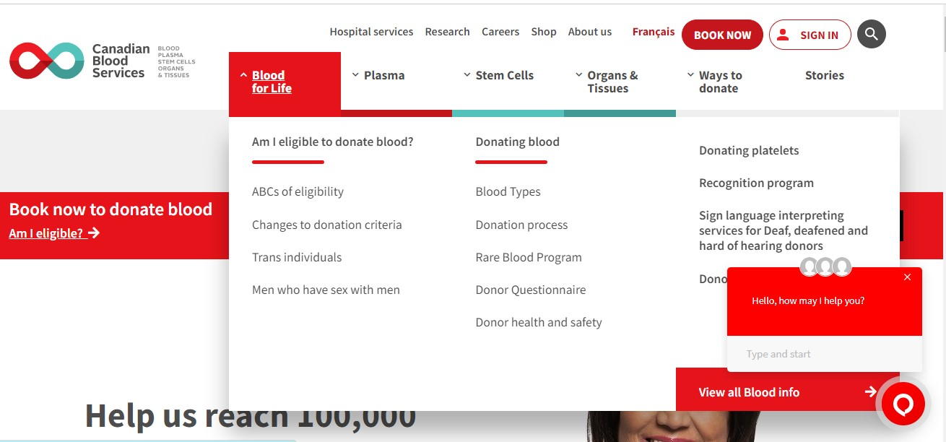

Figure 3.4: The overview of the Blood.ca

Best Features

* Professionally organized and brilliant design.
* Donation time booking system.
* Individual donor can set his own donation measures!
* Works with other medical supports too.
* Have an acknowledgment program for the donors.

Limitations

* Not just for blood services
* Pre-demand donation may.
* Don’t deal with the communication among the medical clinic and donors.
* No private request options.
* No real-time request processing or notification system.
* Do not have any facility to whether the donor is eligible or not.
* No GPS technology has been implemented.
* Do not have notify the donor when they are eligible to donate blood.

### 3.3.5 Donatebloodbd.com

”Donate Blood: Save People and Be Saved” is the motto of the website which started its journey on January 24, 2013. The main purpose of this website is to preserve the information of blood donors. Www.DonateBloodBD.com begins with a dream: ”Anyone in need of a dying patient’s blood can easily contact a blood donor at any time.” Blood donors will be able to register as blood donors on this website, and people in need of blood will be able to find blood donors by searching from this website. With the combined efforts of all, we may be able to save thousands of dying patients.

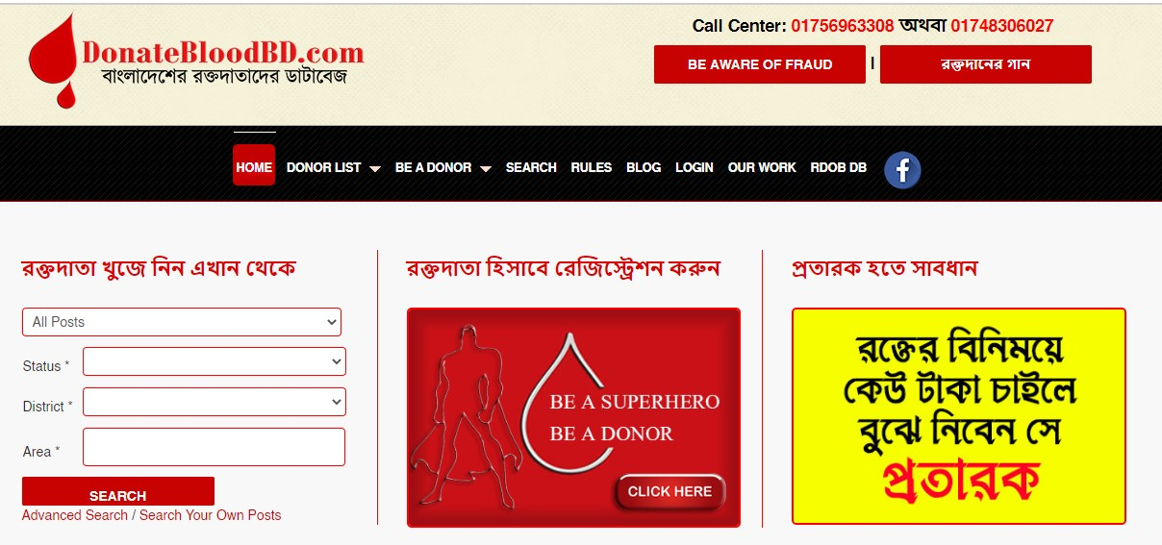

Figure 3.5: The overview of the Donatebloodbd.com

Best Features

* Professionally organized and brilliant design.
* Can see all donor list.
* Export Donor list with contact numbers.
* Direct contact with donors.
* Know about the last donation of donors
* Blog post

Limitations

* No real-time request processing or notification system.
* No GPS technology has been implemented.
* Do not have notify the donor when they are eligible to donate blood.

## 3.4 Recommended Approach

From the above explanation and comparison, obviously the current systems don’t have the necessary features and functionalities. It additionally clears the functionalities and contemplations need to consider for the new proposed system. The GEO-Location

Based Blood Donor Searching System ought to give the features recorded here-

* Attractive and user friendly UI design.
* Implement Restriction on access to the women donor’s information.
* Automatic Email & SMS notification system.
* Donor Identity and verification approval process.
* GPS technology for find nearest donor by using GEO-Location.
* Notify donors when they are eligible for donation.
* Take ta donation history of donors. • Upload medical reports of donor’s.
* Blog post for medical health awareness.
* Direct contact with donors.

Chapter 4

System Requirements Analysis and

Diagram Design

## 4.1 Introduction

A systematic approach to system requirements analysis and diagram design can help to ensure that an e-learning management approach is effective, efficient, and meets the needs of all stakeholders involved in the e-learning process. A proper and complete system need to a proper analysis on functional, non-functional requirements, hardware-software requirements, system working flow, use case design analysis and so on. Therefore, this section is contain the system requirements analysis and diagram design. We tried to find out the all possible solutions and finally choose the best solutions for our system.

## 4.2 Specification and Requirements

Our system has various types of requirements to access it. These are:

* Hardware requirements
* Software requirements

We have tried to sort out the best hardware and software requirements for the system.

Here the requirements:

### 4.2.1 Hardware Requirements

The hardware requirements to access our system is given below:

* Minimum 2GB RAM
* Minimum 4GB storage
* Dual Core Processor
* Internet Connection

### 4.2.2 Software Requirements

Prototype Design

* Design UI/UX using Figma online tools

Frontend Development

"dependencies": {

"@headlessui/react": "^1.7.7",

"@jitsi/react-sdk": "^1.3.0",

"@next-auth/prisma-adapter": "^1.0.5",

"@next/font": "13.1.1",

"@prisma/client": "^4.8.1",

"@reduxjs/toolkit": "^1.9.1",

"@types/bcryptjs": "^2.4.2",

"@types/formidable": "^2.0.5",

"@types/jsonwebtoken": "^9.0.1",

"@types/node": "18.11.18",

"@types/nodemailer": "^6.4.7",

"@types/react": "18.0.26",

"@types/react-dom": "18.0.10",

"axios": "^1.2.2",

"bcryptjs": "^2.4.3",

"eslint": "8.31.0",

"eslint-config-next": "13.1.1",

"file-type": "^18.2.0",

"formidable": "^2.1.1",

"jodit-react": "^1.3.32",

"jsonwebtoken": "^9.0.0",

"next": "13.1.1",

"next-auth": "^4.18.7",

"nodemailer": "^6.9.0",

"prop-types": "^15.8.1",

"react": "18.2.0",

"react-dom": "18.2.0",

"react-icons": "^4.7.1",

"react-query": "^3.39.2",

"react-redux": "^8.0.5",

"react-rte": "^0.16.5",

"react-toastify": "^9.1.1",

"short-uuid": "^4.2.2",

"typescript": "4.9.4"

},

"devDependencies": {

"@types/react-rte": "^0.16.4",

"autoprefixer": "^10.4.13",

"postcss": "^8.4.20",

"prisma": "^4.8.1",

"tailwindcss": "^3.2.4"

}

Data Base:

MySql

* HTML5
* CSS
* Bootstrap4
* JavaScript
* JQuery

Backend Development

* Asp.net Core
* C#
* MSSQL
* API

Deployment:

* IIS (Internet Information System)

## 4.3 Methodology

The iterative model is a software development methodology that involves repeating a series of development and testing cycles, with each cycle building upon the previous one. This approach is particularly useful for complex projects, such as e-learning management systems, where requirements may change frequently and feedback from users is critical.

**Why we use Iterative Model?**

* Generates working software quickly and early during the software life cycle.
* More flexible – less costly to change scope and requirements.
* Easier to test and debug during a smaller iteration.
* Easier to manage risk because risky pieces are identified and handled during its iteration.
* Each iteration is an easily managed milestone.

The iterative model is well-suited for e-learning management approach projects because it allows for requirements gathering in stages, rapid development and feedback, flexibility and adaptability, and quality assurance at every stage of the development process.

**Testing**

**Initial Planning**

**Planning**

**Requirement**

**Analysis & designing**

**Implementation**

**Deployment**

**Evaluation**

Iterative Model

Figure 4.1: Iterative Methodology

## 4.4 Gantt Chart

Here is the Gantt chart of our system. It contain the full schedule of our system development from the beginning day to final deployment day.

|  |  |  |  |  |  |  |  |  |  |  |  |  |
| --- | --- | --- | --- | --- | --- | --- | --- | --- | --- | --- | --- | --- |
|  | 1st Progress | | | | 2nd Progress | | | | 3rd Progress | | | |
|  | Feb | Mar | Apr | May | June | July | Aug | Sep | Oct | Nov | Dec | Jan |
| Planning |  |  |  |  |  |  |  |  |  |  |  |  |
| Requirement Analysis |  |  |  |  |  |  |  |  |  |  |  |  |
| Design & Implementation |  |  |  |  |  |  |  |  |  |  |  |  |
| Testing |  |  |  |  |  |  |  |  |  |  |  |  |
| Final Change |  |  |  |  |  |  |  |  |  |  |  |  |
| Finalize |  |  |  |  |  |  |  |  |  |  |  |  |

Figure 4.2: Gantt Chart

## 4.5 Functional Requirements

Functional requirements consider the main features demanded by the clients and these are consider as the main module of the system. The functional requirements of GEO Location Based Blood Donor Searching System are given below:

### 4.5.1 Admin

* Login
* Manage Profile
* Manage Users
* Create Another Admin
* Create Teacher
* Create Students
* Change Password

### 4.5.2 Teacher

* Login
* Manage Profile
* Crate Class
* Join Class
* Join Students
* Upload Materials
* Create Notification
* Send massage
* Create Online Class
* Create Quiz
* Evaluate Quiz
* Create Attendance

### 4.5.3 Students

* Login
* Manage Profile
* Join Class
* Read Materials
* Read Notification
* Send massage
* Join Online Class
* Take Notes
* Give Quiz
* See Quiz Result

## 4.6 Non-Functional Requirements

Non-functional requirements specify the performance, security, usability, UI/UX, and other quality characteristics of a system. Here are some non-functional requirements for our e-learning management approach project:

### 4.6.1 Security

ELMA is a fully secured system. Only authorized students can access to ELMA by using provided valid email and password. The password is being restricted and encrypted.

### 4.6.2 Usability

The usability of our system is well accurate. With the quality internet, user will get the full advantages from our system.

### 4.6.3 User-friendly UI

We have designed our system considering the Flexible User Interface. This system is easily understandable to all users. Buttons are also make using understandable color coding.

### 4.6.4 Responsive

Our system is responsive to all devices such as Mobile, Tab, Laptop and Desktop. All Users are not same they aren’t always use same devices. Users will see the accurate User Interface regardless of the device they are using.

### 4.6.5 Easy to Modification

If needed any future modification if both frontend & backend, developers can easily modify the system. Because we design well-structured front end and backend design.

## 4.7 Limitations

Our e-learning management approach projects offer many benefits, there are also limitations that should be considered. Some of the limitations of our e-learning management approach projects are:

Automated Students Progress Tracking: Automated Students Progress Tracking is an e-learning management approach project that uses technology to track and monitor the progress of students in an e-learning course but we can’t provide this service yet.

Technical limitations: E-learning management approach projects rely on technology to deliver content, which can sometimes be unreliable. Technical issues such as slow internet speeds, server downtime, or software compatibility issues can affect the user experience.

The biggest limitation of our system is, the user must have to access of internet. Especially in rural area of our country where the internet is not available yet. So, network failure will be hampered to the usability of users. Secondly, the users of our system is need minimum of education level, so that they can use the system properly.

## 4.8 Use Case Diagram

Use case diagram is a graphical view of user’s possible interaction with the system modules and features. Here is the use case diagram of our system.

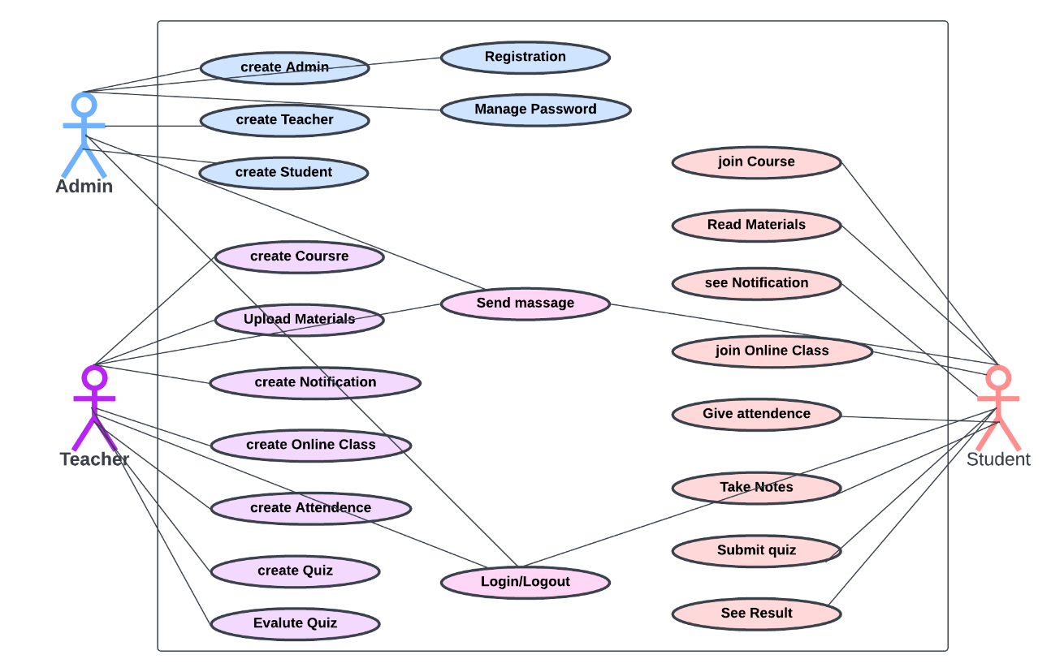Figure 4.3: Use Case Diagram

## 4.9 DFD Model

Data Flow Diagram is the best way to represent the total data flow process of a system. DFD also provide the input, output, users, entity and the total process of them. DFD has the various level.

### 4.9.1 DFD Level – 0

Zero Level DFD: Provides an overview of the system's major components and the flow of data between them.

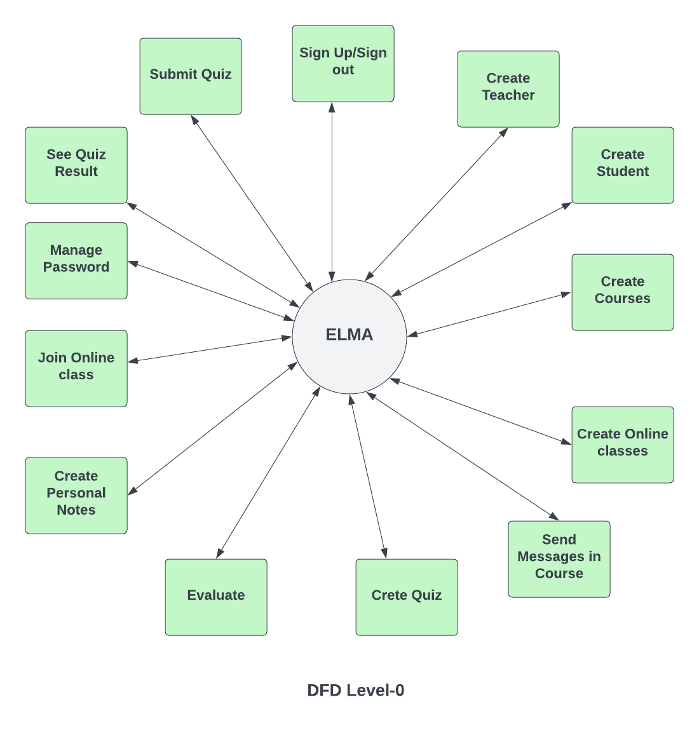

Figure 4.4: DFD Model Level - 0

### 4.9.2 DFD Level - 1

1st Level DFD: Provides a more detailed view of the system's functionality and the flow of data between different modules

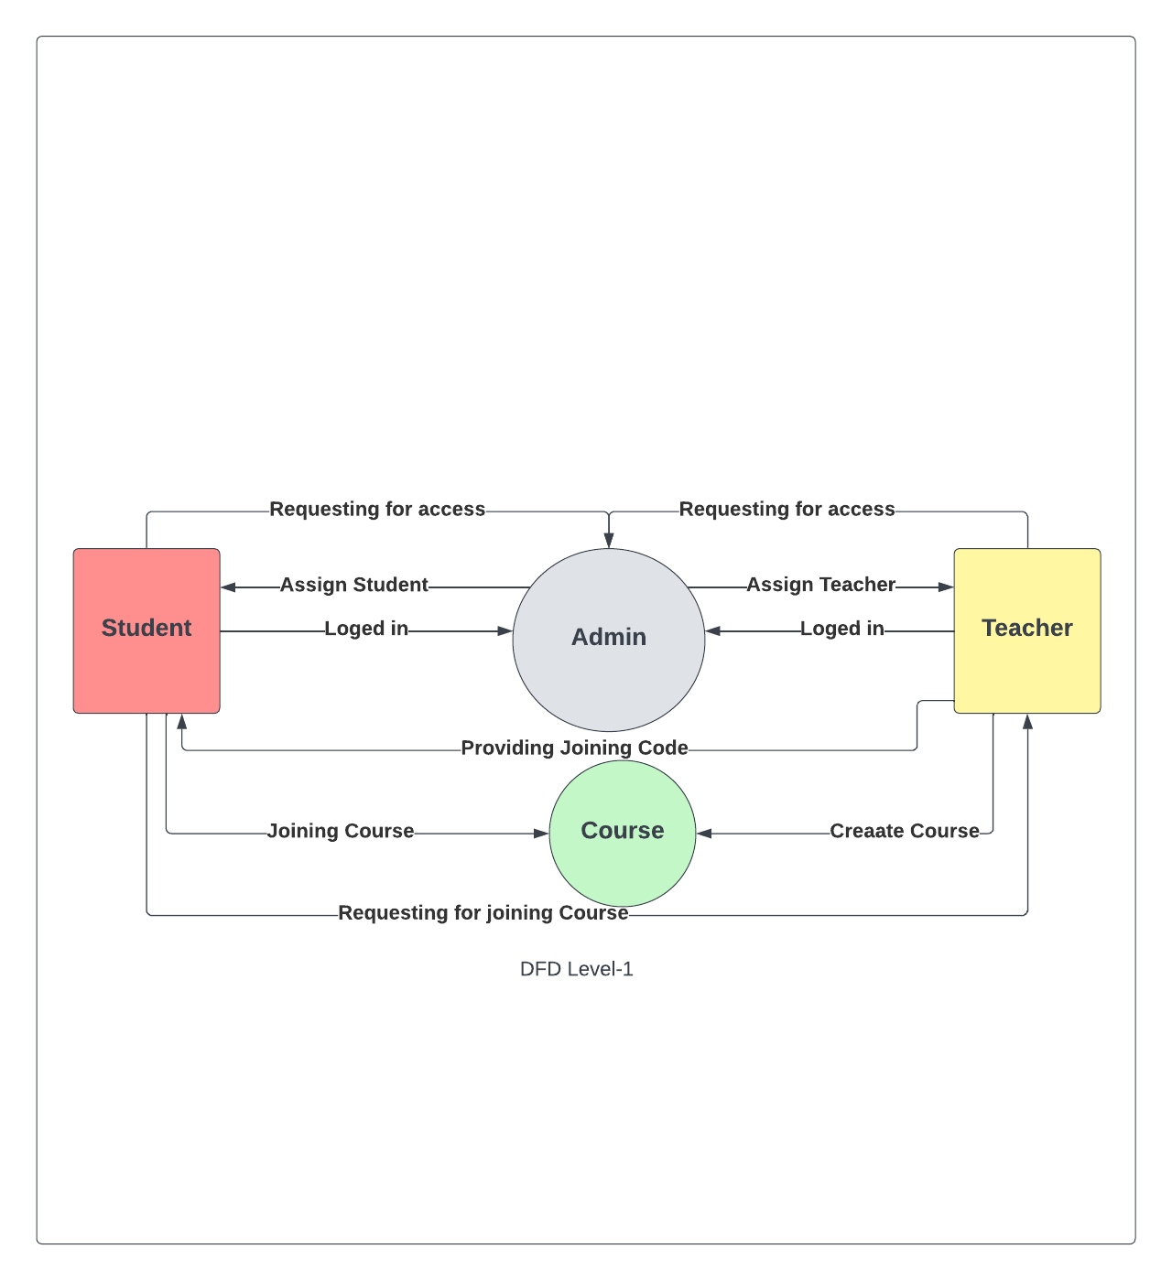

Figure 4.5: DFD Model Level –

### 4.9.3 DFD Level – 2

2nd Level DFD: Provides an even more detailed view of the system's functionality, including the flow of data between different sub-modules

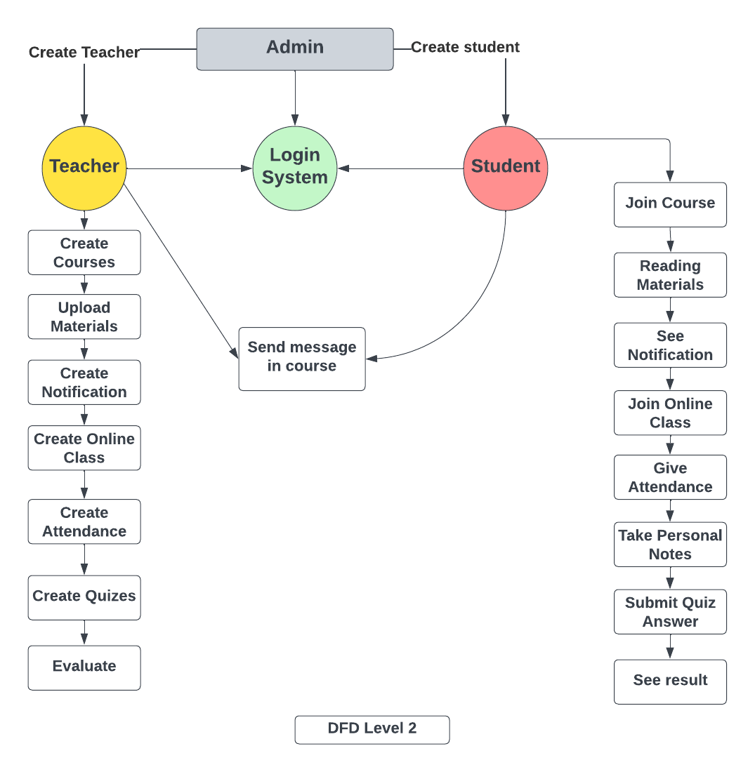

Figure 4.6: DFD Model Level – 2

## 4.10 Database Model

The ERD for the e-learning management system is designed to show the relationships between different entities in the system. These entities include students, courses, content, and assessments. The ERD shows how these entities are related to each other, and the types of relationships that exist between them. The ERD also shows the relationships between entities and their attributes.

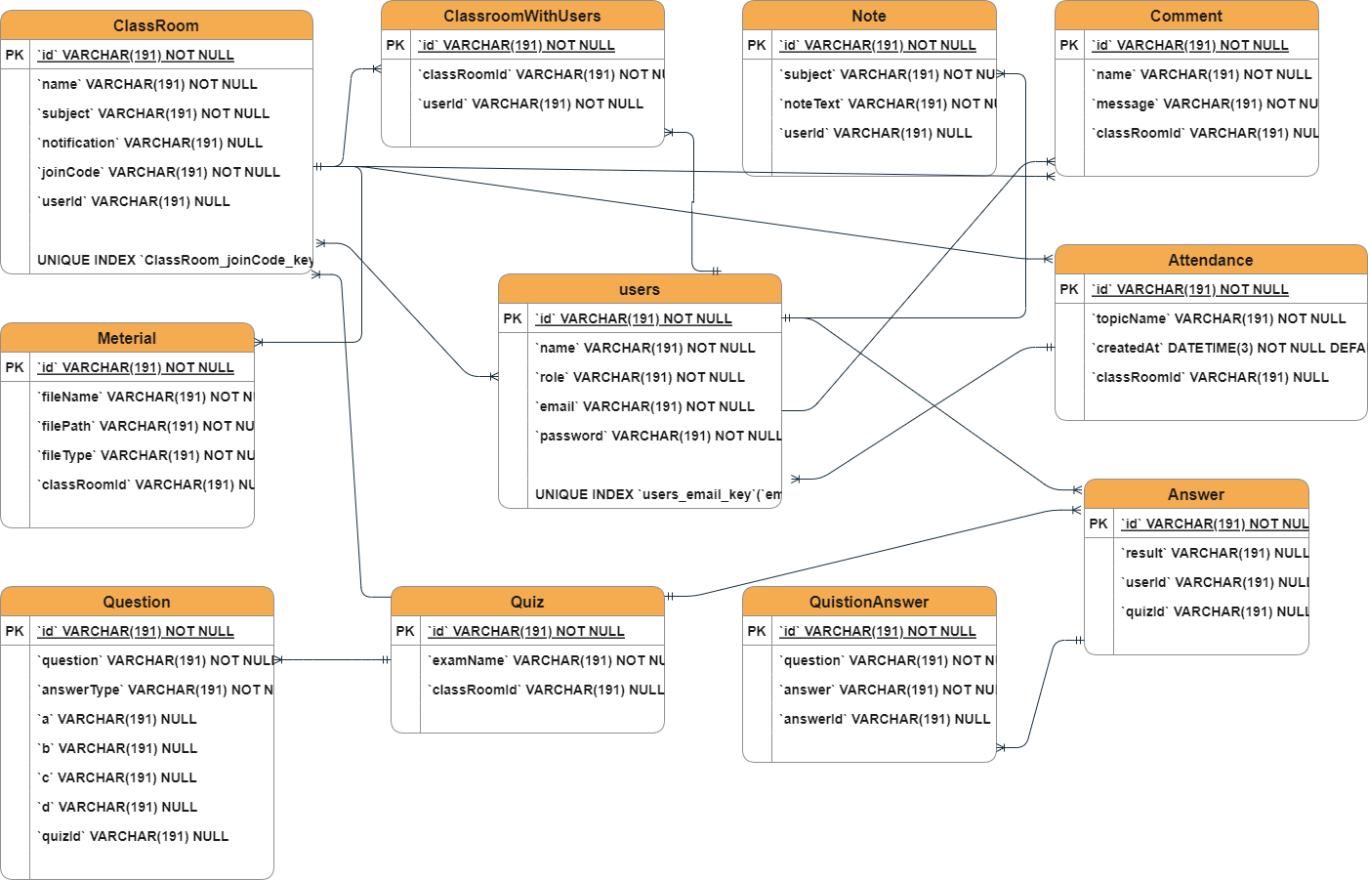

Figure 4.6: Database Model Design

Chapter 5

System Interface Design and

Implementation

## 5.1 Introduction

We are going to discuss about the system requirements analysis, design and implementation. This Phase is began with a proper analysis about the functional and nonfunctional requirements. We have tried to make possible all effective solutions for design and implementation criteria. Then we choose a best solution and transform it to make a complete, efficient and user friendly system. An effective system interface design and implementation process involves understanding the needs of the users, defining clear requirements, developing an intuitive and visually appealing design, integrating the interface with the underlying software, and testing and evaluating the interface to ensure that it is user-friendly and effective. In this Chapter we are going to discuss about the system requirements analysis, design and implementation. This Phase is began with a proper analysis about the functional and nonfunctional requirements. We have tried to make possible all effective solutions for design and implementation criteria. Then we choose a best solution and transform it to make a complete, efficient and user friendly system. In this section we are going to introduce our system all interface designs and their functionality.

## 5.2 Design Process

At the initial stage wire framing is being used for system layout structure design. Here we make our planning and system layout thoughts. Right after that we moved to figma for making screen layout mockups and make connection between the layouts. From here we test this prototype by some user perspective. Then we finalize the mockups and started to front-end design. The first step in system interface design is to conduct user research to understand the needs, goals, and behaviors of the users. Based on the user research, define the requirements for the system interface. Identify the features and functions that are necessary to meet the needs of the users. Use these requirements to create a design brief. Here we make our planning and system layout thoughts scratching. Right after that we moved to figma for making screen layout mockups and make connection between the layouts. From here we test this prototype by some user perspective. Then we finalize the mockups and started to front-end design.

## 5.3 Frontend Development

First of all, we developed a prototype of our project or system using Figma online tools, then developed user interface or frontend using HTML5, Bootstrap4 , JavaScript and JQuery. Frontend development refers to the creation of the user interface and user experience of a website or web application. It involves the use of various programming languages, frameworks, and tools to develop the client-side of a web application that is visible and interactive to users. For frontend development firstly, we developed a prototype of our project or system using Figma online tools then we developed user interface or frontend using Javascript, React js , Next js and Tailwind css for designing.

## 5.4 Backend Development

We have used dot net framework to develop the backend of our system, Asp.net Core,

C sharp as the programming language, Microsoft SQL to manage the database, and Google API for donor searching using GEO Location. Backend development refers to the creation of the server-side of a web application, which handles the logic and processing that takes place on the server, as opposed to the client-side that is visible and interactive to users. Backend development involves the use of various programming languages, frameworks, and tools to create the backend logic of a web application. For backend development we have used Next js api which React Library based Full stack library. Node js runtime environment based Javascript Language. MySQL to manage the database.

## 5.5 System Designs

In this section we are going to introduce our system all interface designs and their

functionality.

### 5.5.1 Home Page

When the regular users come into our system, firstly they will see our system’s home page. Our system home page is containing the following module buttons:

* Home
* About Us
* Blood Request
* Search Donor
* Blog
* Contact Us
* Donor Registration
* Login

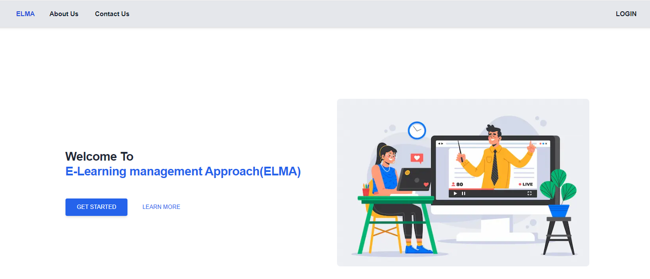

Figure 5.1: Home Page

### 5.5.2 About Us

The users will get a brief idea about our system as well as our mission and vision.

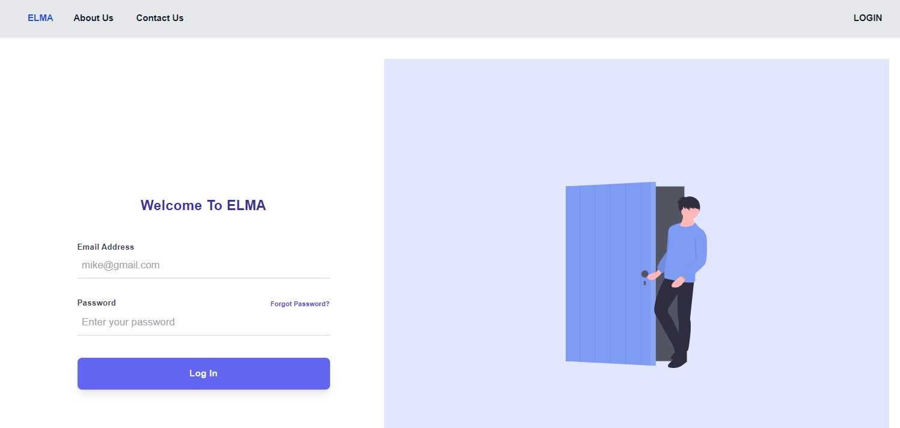

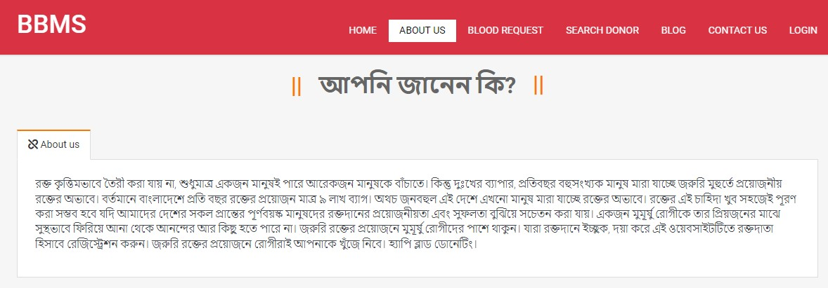

Figure 5.2: About Us Page

### 5.5.3 Blood Request

Here, the blood seekers can submit a blood request to the system admin. We also called it advance blood booking module. Blood seekers have to fillip the require information field and then submit the request to the system admin. Having said that this request would not goto to the donor until and unless the admin approved this request.

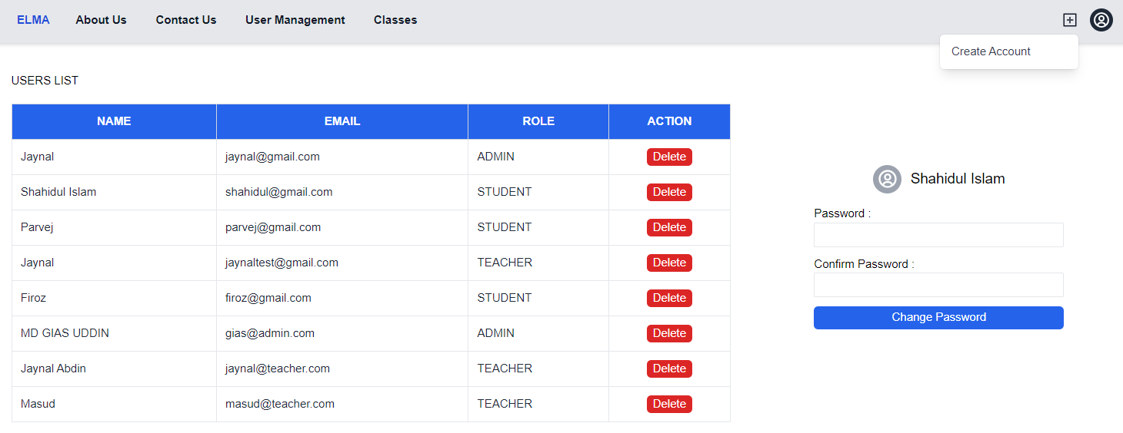

Figure 5.3: Blood Request Page

### 5.5.4 Search Donor

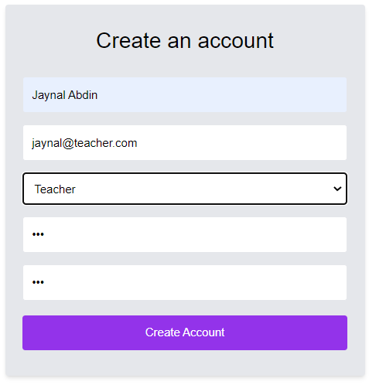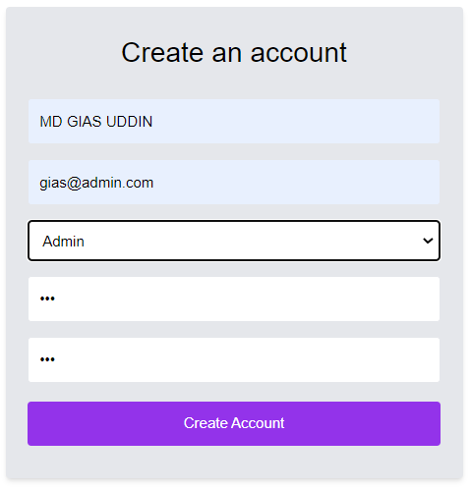 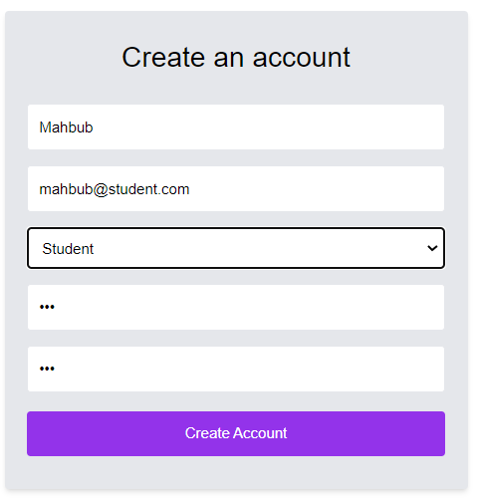

Figure 5.4: Search Donor Page

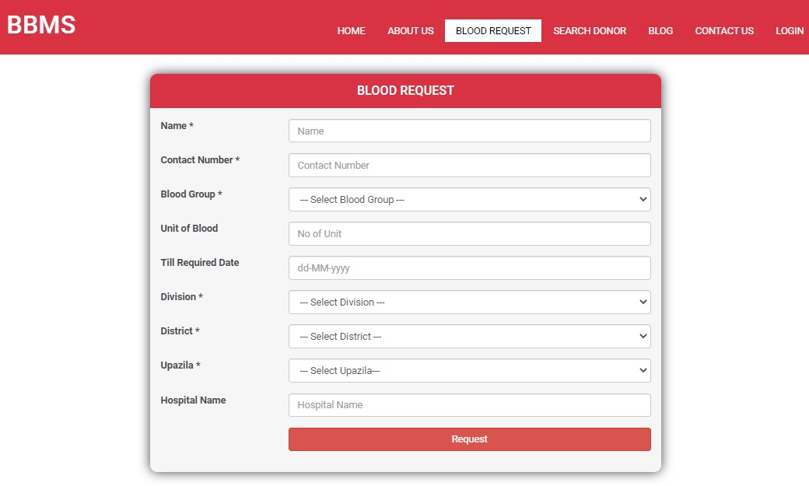

This the most highlighted feature of our system. A blood seeker can find a blood donor in his/her fingertips by using the GPS system. When a user comes into this page, the system will wanted the location permission of the user. Then user just need to choose the required blood group. Then system will find the available blood donor in the nearest

5-10 KM radius area.

### 5.5.5 Donor Registration

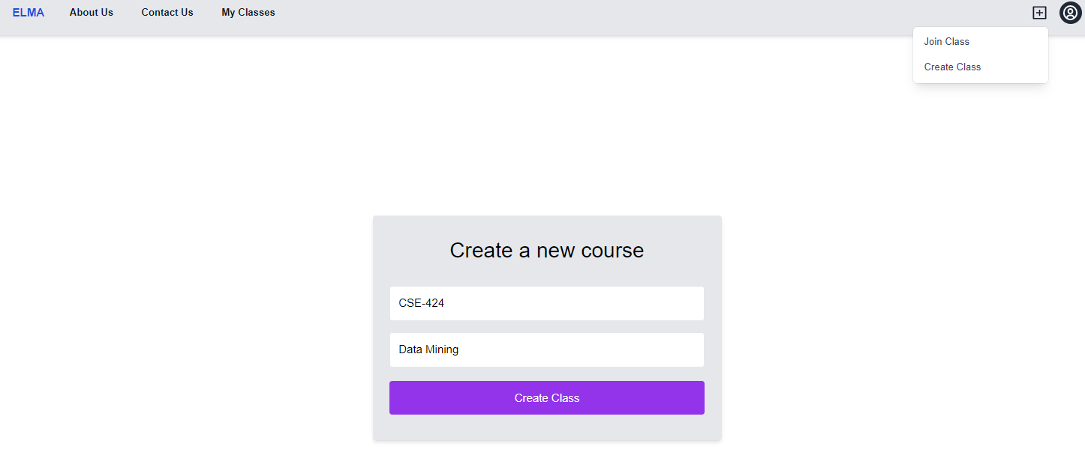

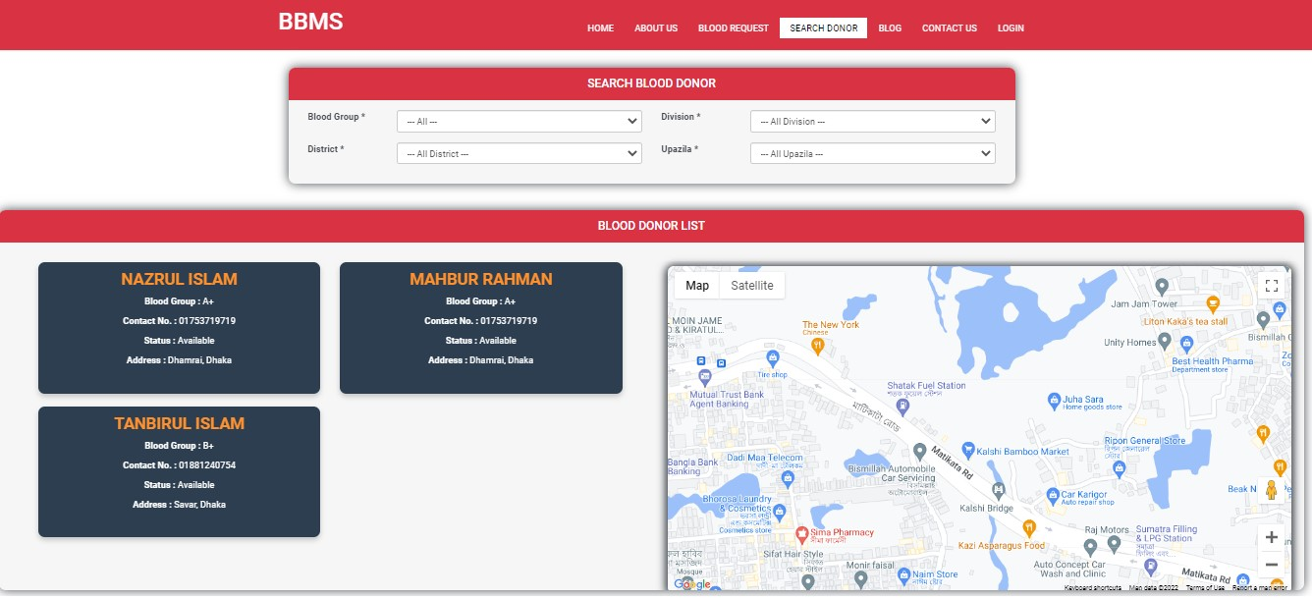

Figure 5.5: Search Donor Page

### 5.5.6 Donor Registration

When a donor wanted to registration to our system, the need to click on “Join as a blood donor” button on home page. Then they need to provide a valid contact number to get the OTP from the system.

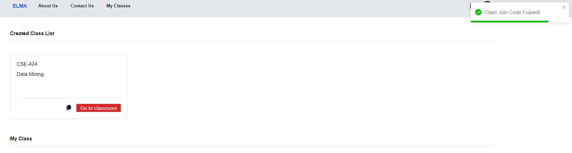

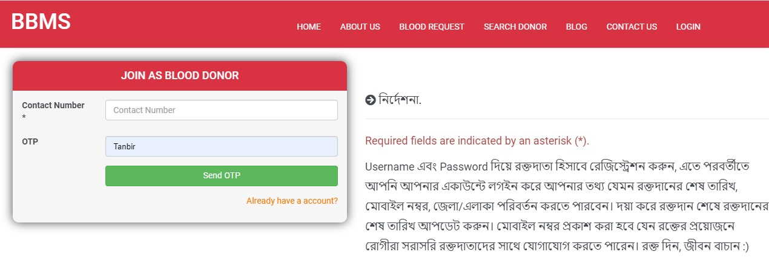

Figure 5.6: Donor Registration (OTP Page)

After getting the OTP from System and put on OTP field, Donor will be redirect to donor information page. Here, donor have to put their information and location. System will convert their location latitude and longitude value and store it on system database. After giving all information including user name and password donor need to click on register button. Then they will became a registered blood donor.

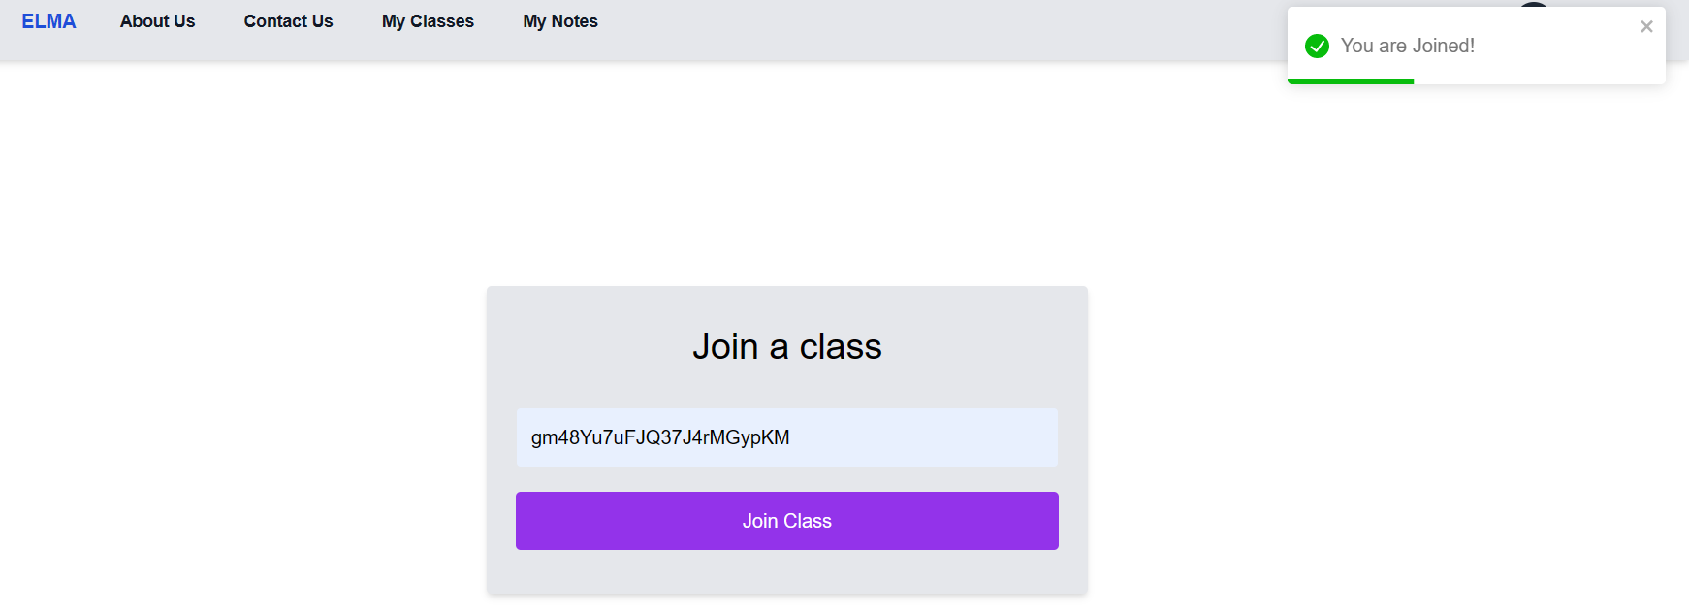

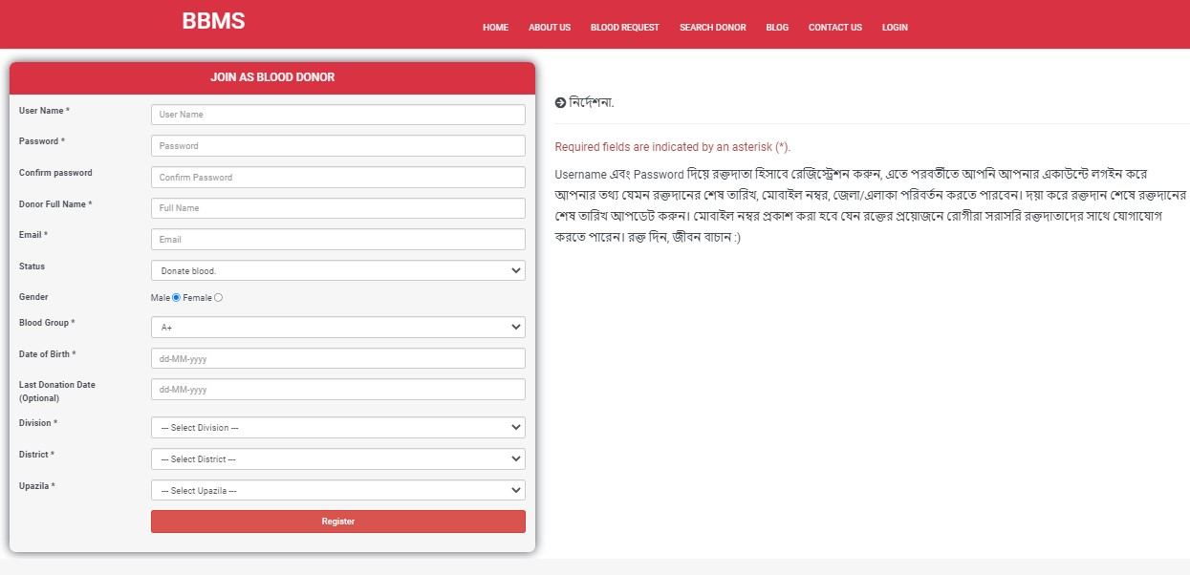

Figure 5.6: Donor Registration (Information Page)

### 5.5.7 Blog

Here, the users can see the blogs about the blood donation, health tips and many other

articles.

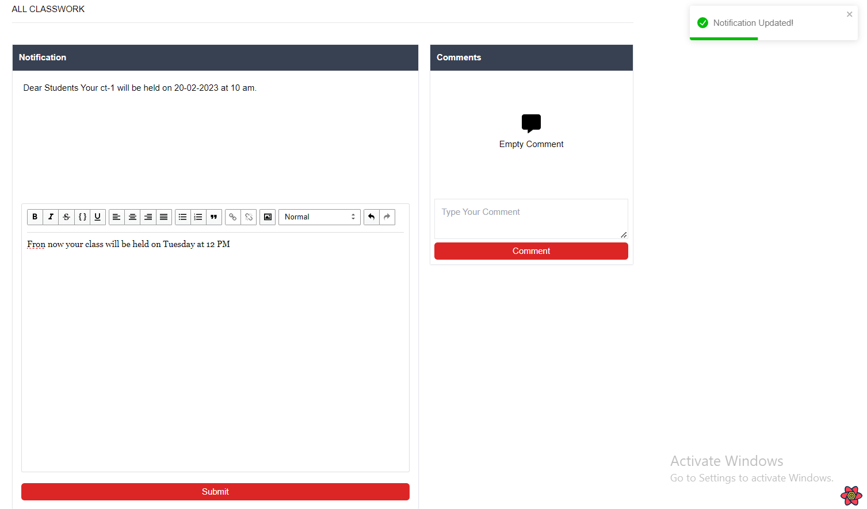

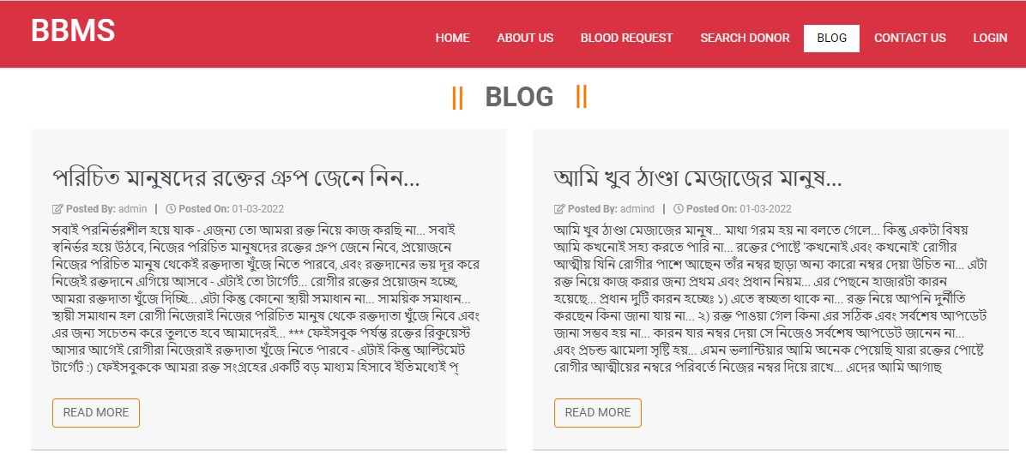

Figure 5.7: Blog Page

### 5.5.8 Create Online Class

From this page, any user can contact with the system admin. Users can find out our system office address, facebook page, twitter, LinkedIn, Instagram and so on. If the users wanted to send any message to system admin, they need to put their name, email and put the text message and press the “submit” button.

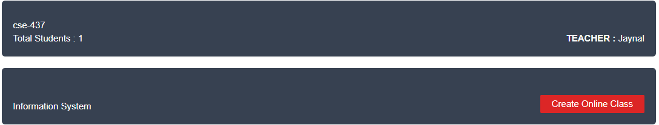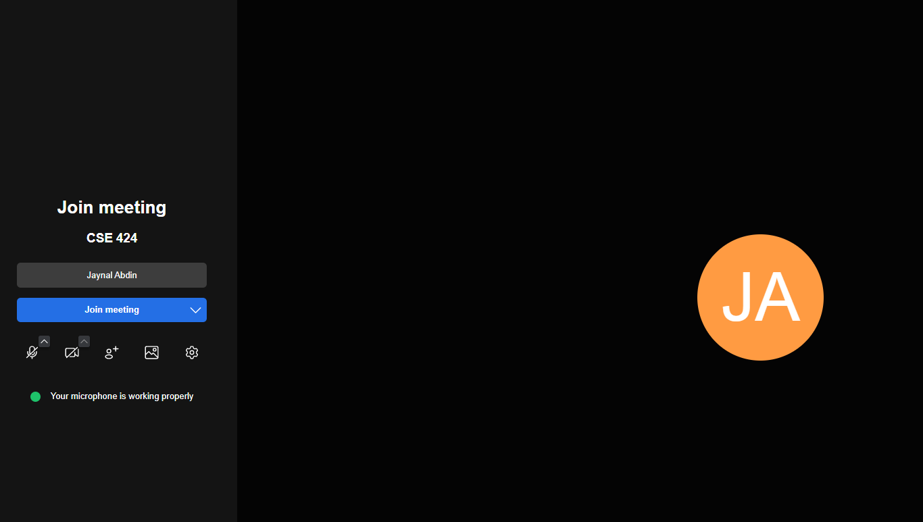

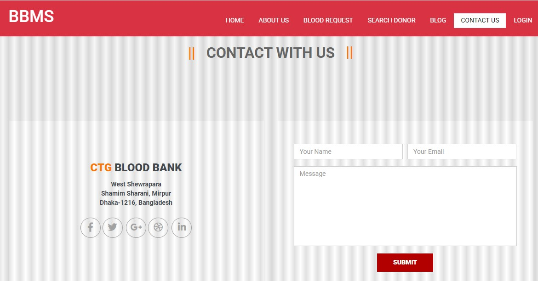

Figure 5.8: Contact Us Page

### 5.5.9 Join Online Class

From this page the donor and the admin can login to their profile. Admin and donor both need to put their valid user name and password. From this page a user can registration as a donor. If any user forget their password, then they can reset their password from login page.

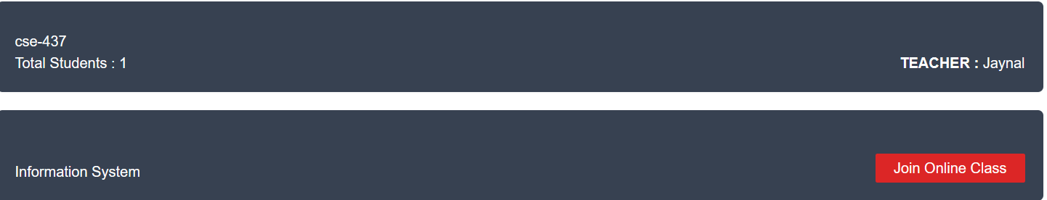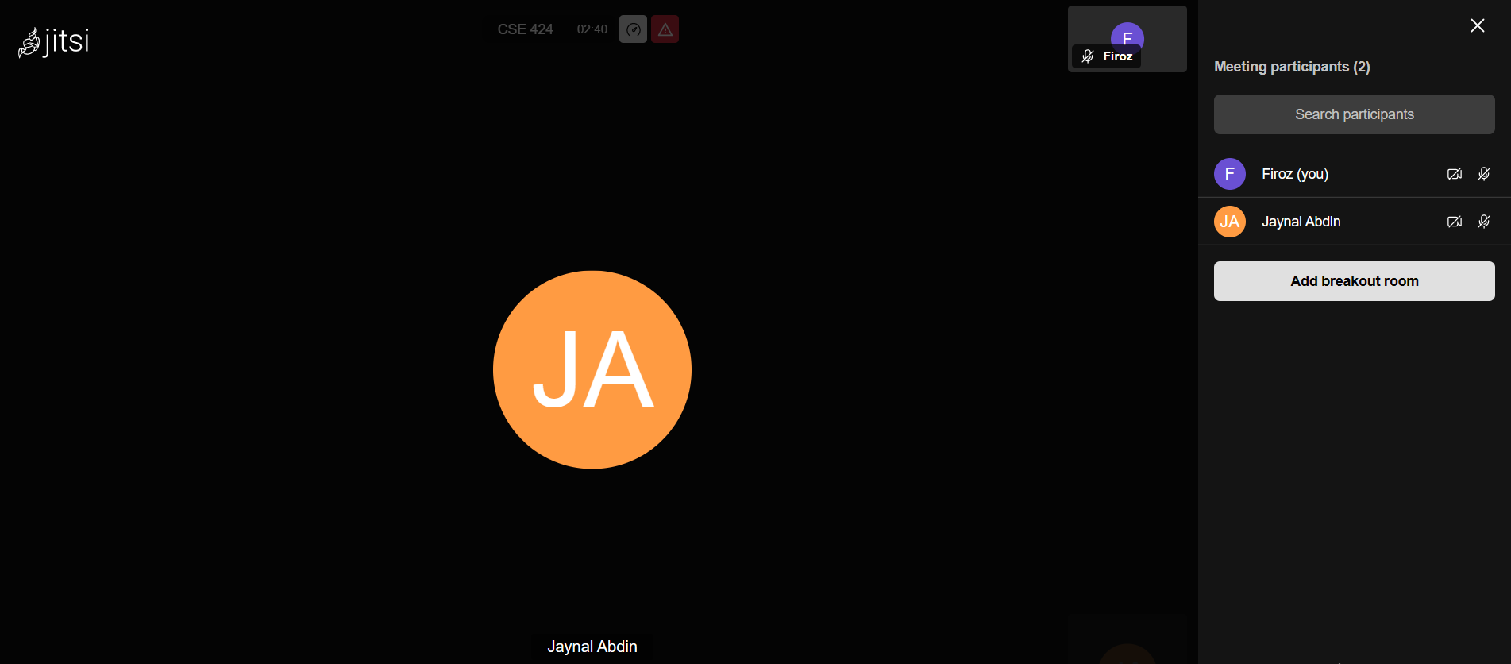

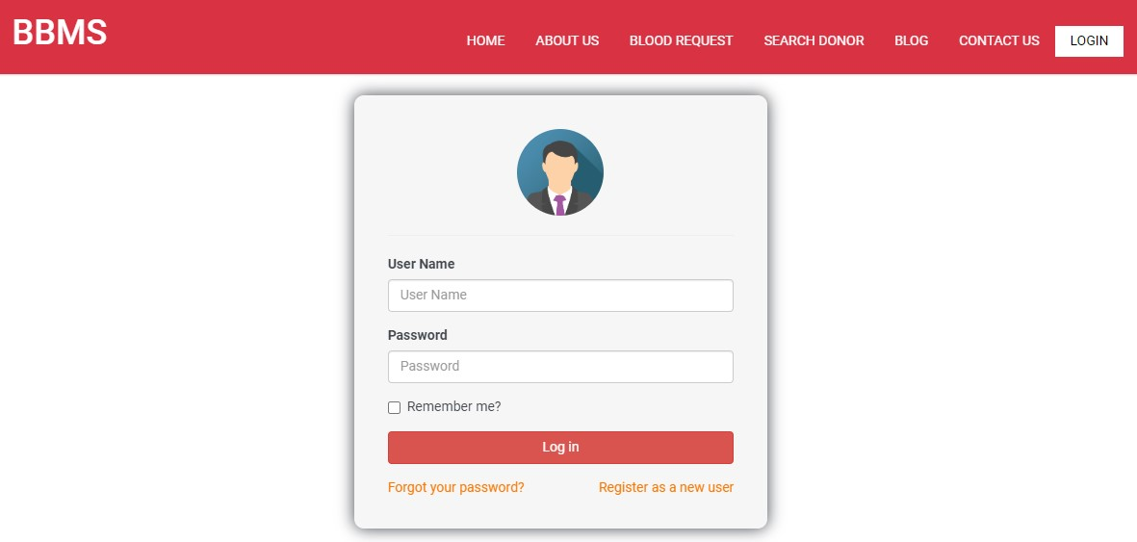

Figure 5.9: Login Page

### 5.5.10 Upload & Read Material

If user need to reset their password, they need to click on reset password from login page. Then system will wanted their user name. if the user name is valid, then they will get a password reset mail to their email with the full information for reset password.

User can easily reset their password from here.

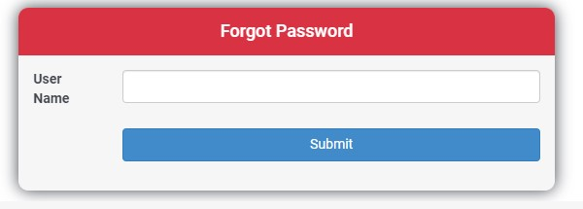

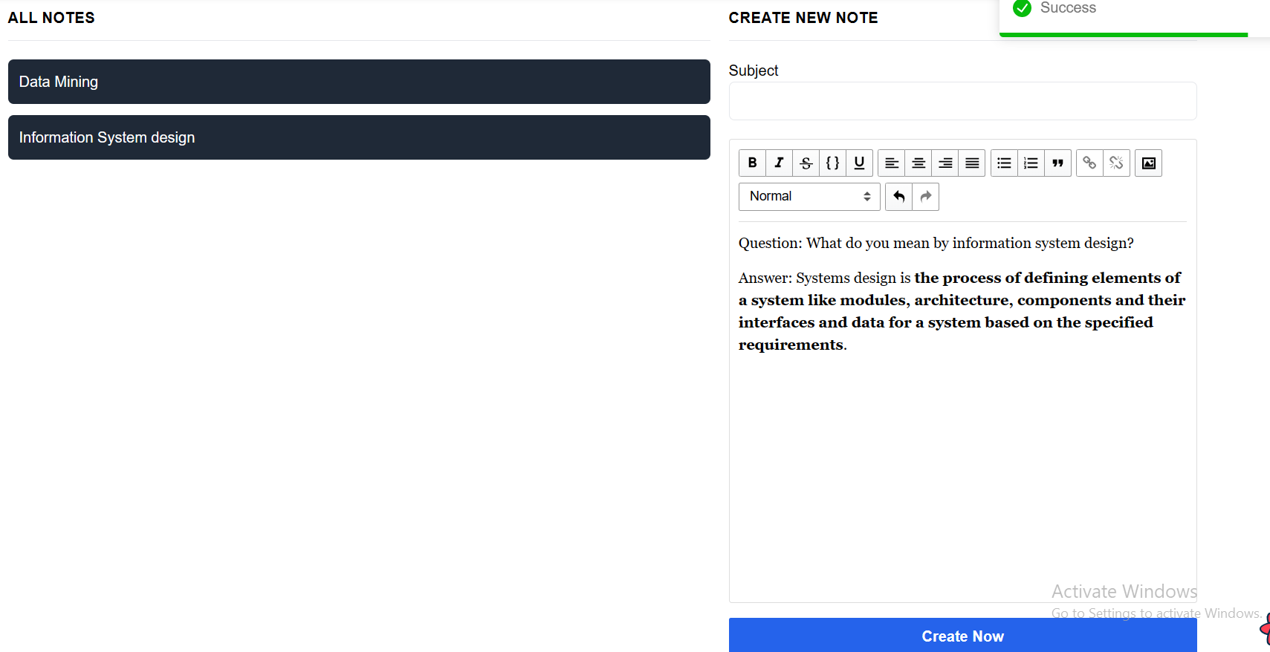

Read and Manage Notes

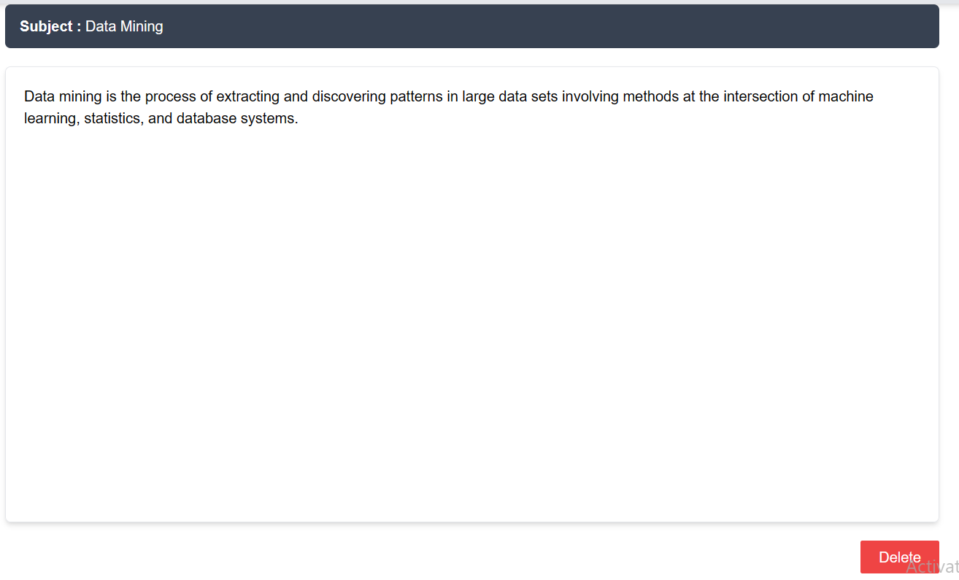

Figure 5.10: Password Reset Page

### 5.5.11 Add Donation

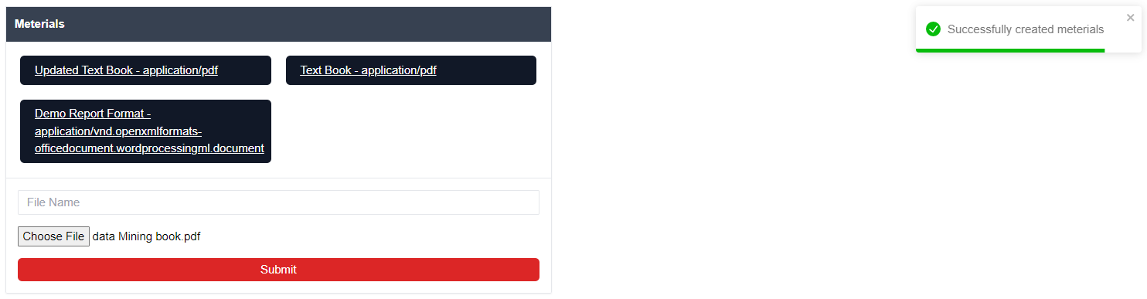

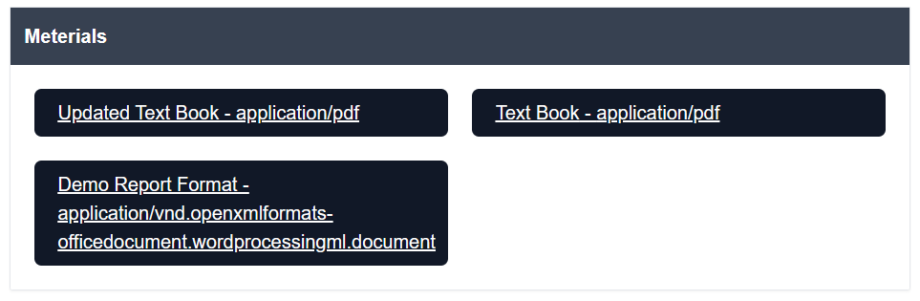

Figure 5.11: Donor Dashboard Page

### 5.5.12 Add Donation

In this page, donors can add their blood donation history. The system will count 120 days from last donation date and show this donor not eligible for donate. After 120 days of last donation system will send availability notification message to the donors.

Figure 5.12: Add Blood Donation Page

### 5.5.12 Donation History

From this page donors can see their donation history. And also add the donation from this page. Donor can see the list by ascending and descending order.

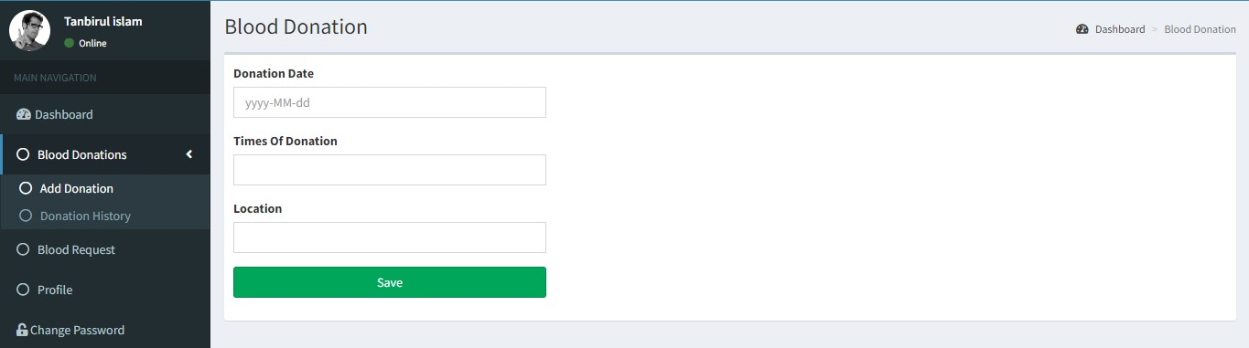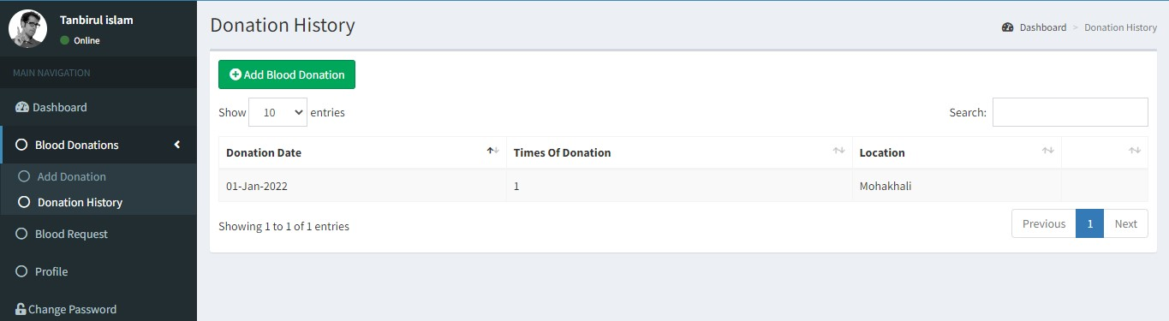

Figure 5.13: Donation History Page

### 5.5.13 Blood Request

In this page, donor can see the approved blood request as the same blood group of them. Here they will the patient all information. They can contact them from here. Donor can see the list by ascending and descending order.

Figure 5.14: See Blood Request Page

### 5.5.14 ProfileFrom this page, donor can update their personal information.

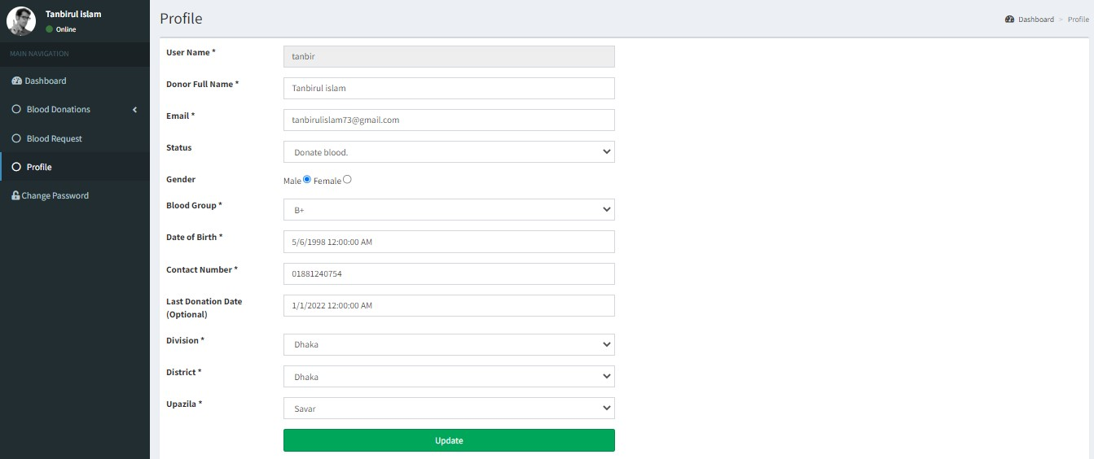

Figure 5.15: Donor Profile Page

### 5.5.15 Admin Dashboard

Here is the admin dashboard of our system. Admin can see all blood donor in blood group wise. Also can see the total request and pending request. Admin can go to pending request by click on pending request in dashboard.

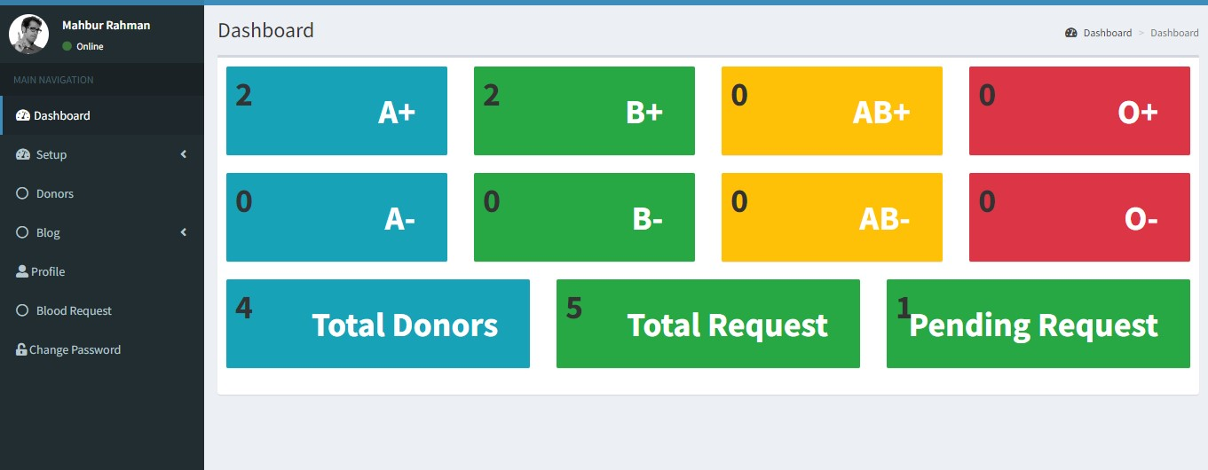

Figure 5.16: Admin Dashboard Page

### 5.5.16 Setup

In this section admin can setup many things as like Blood group, Divisions, Districts, Upazila.

5.5.16.1 Blood Group Setup

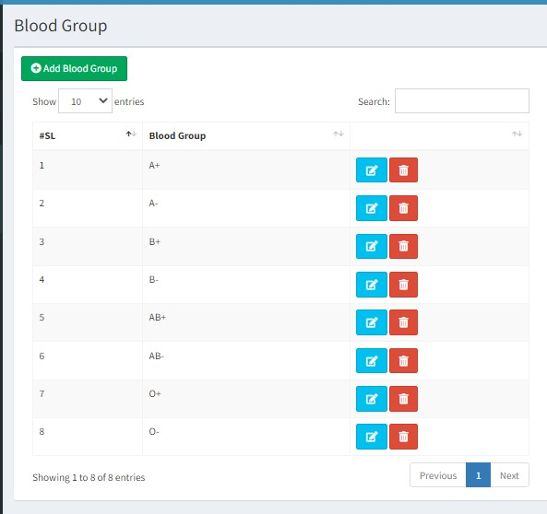

Figure 5.17: Blood Group Setup

5.5.16.2 Division Setup

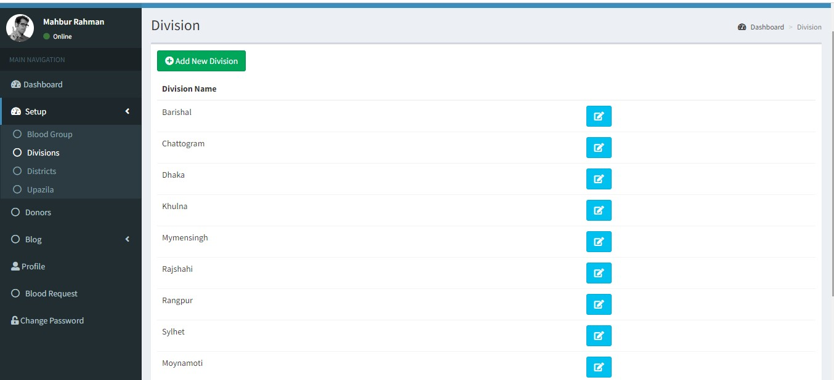

Figure 5.18: Division Setup 5.5.16.3 Districts Setup

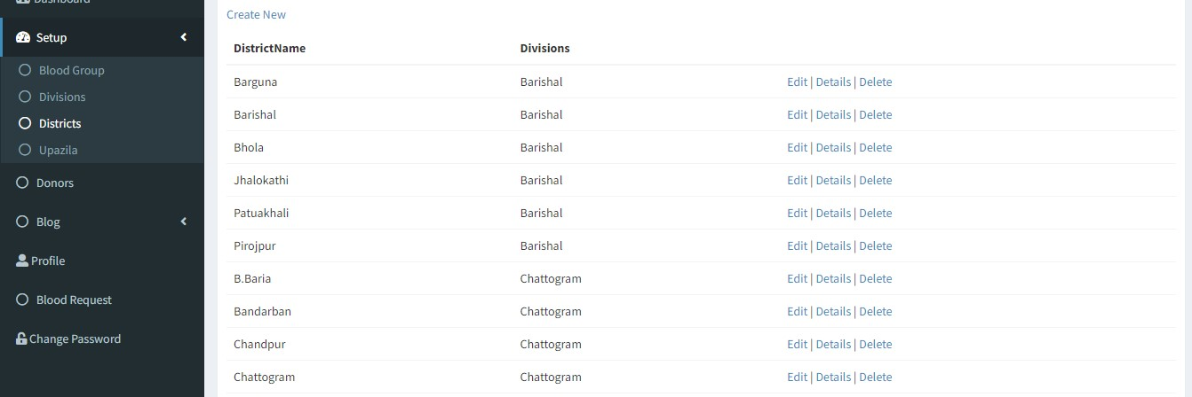

Figure 5.19: Districts Setup

5.5.16.4 Upazila Setup

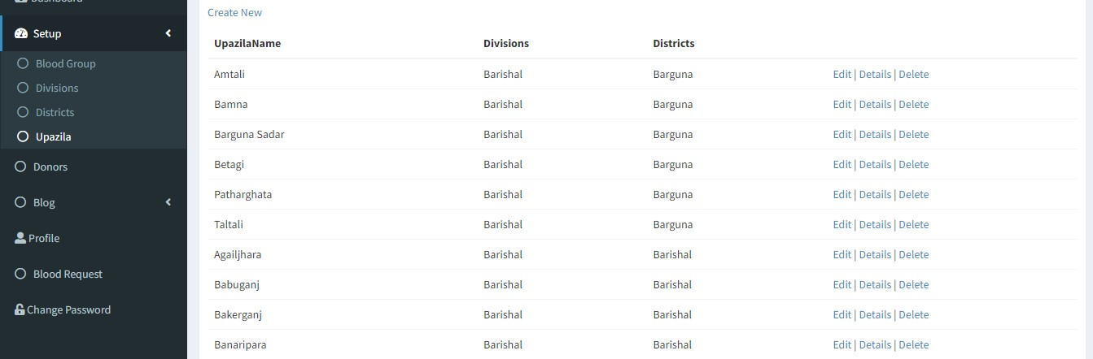

Figure 5.20: Upazila Setup

### 5.5.17 Manage Donors

From here admin can manage the donors. Admin can update any data of donors and also can remove donor from system.

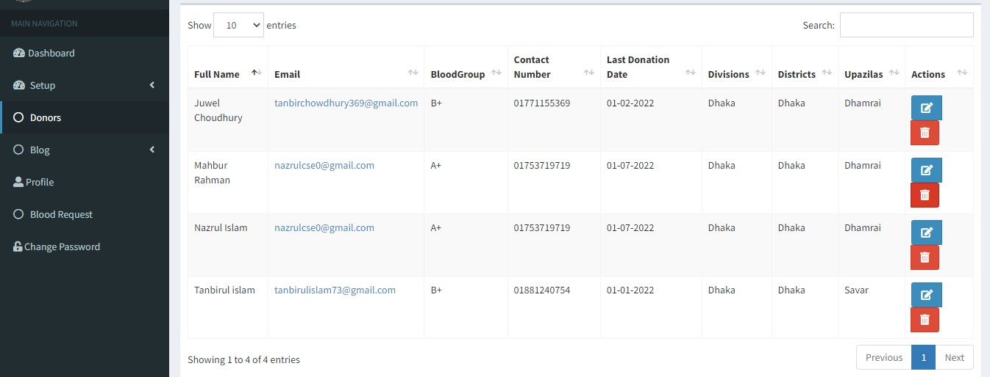

Figure 5.21: Donor Management

### 5.5.18 Blog

Here admin can add blog and see the blog list. From blog list admin can edit a delete the blogs.

5.5.18.1 Add Blog

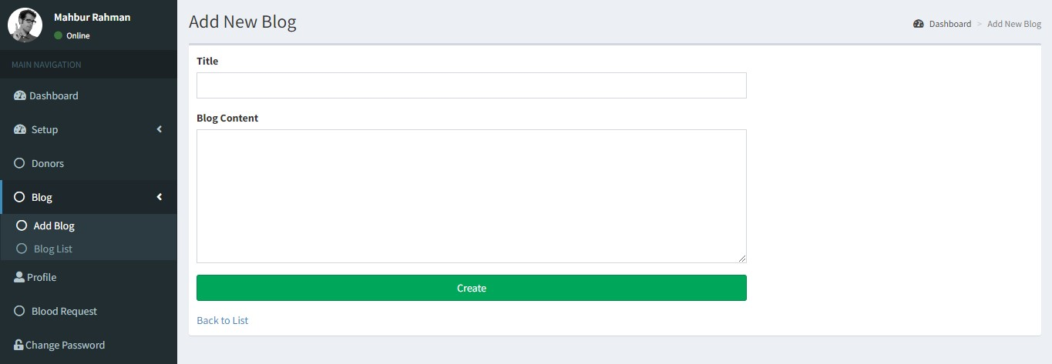

Figure 5.22: Add Blog

5.5.18.2 Blog List

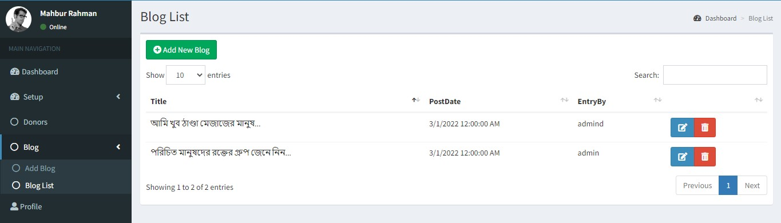

Figure 5.23: Blog List

### 5.5.19 Profile

Admin can update their personal information from admin profile page.

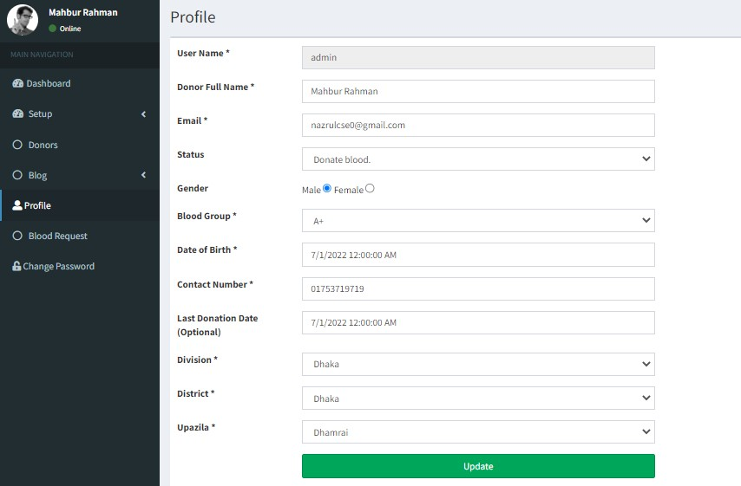

Figure 5.24: Admin Profile Page

### 5.5.20 Blood Request

In this page, admin can see the all blood request placed by blood seekers. Admin will verify this request and can approve or reject the blood request. When approve the request, then all donor of this particular group will get the notification and can see blood request on their profile.

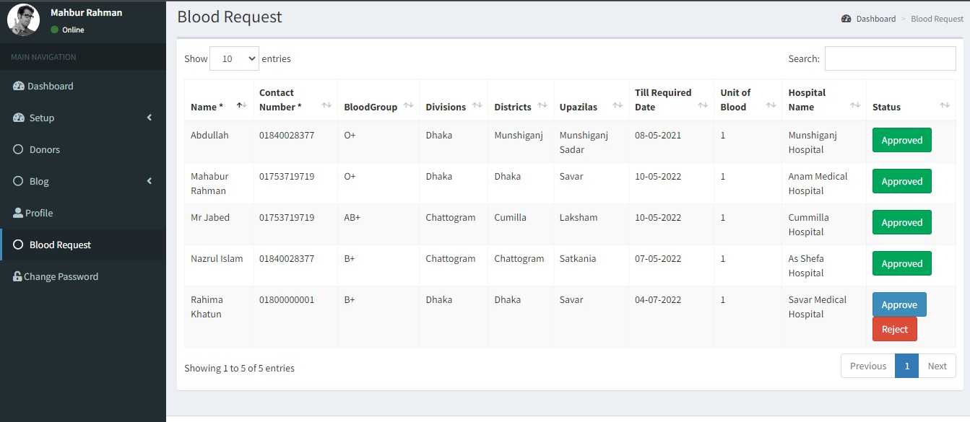

Figure 5.25: Blood Request Page

Chapter 6

Test Case

## 6.1 Introduction

To development a complete and efficient system, software testing plays a vital role on it. For making the system more responsive, test plan should apply in every section of a system planning and these testing should be approved by the developer and users. In our system we applied many types of testing plan.

## 6.2 Test Case Summary

We have generated total of 98 test cases. Almost all test cases are working efficiently. Having said that google mapping is a 3rd party API. So, there are too many limitation. It works based on networks and location. As we know that 3rd party google API always not giving the accurate location information. And our password reset API has been working and dependent on API. Sometimes it may take some times to provide the OTP and email to the users because of server errors.

## 6.3 Test Cases

In this section we are going to generate the test case in an international standard test case format.

Table 6.1: Registration

|  |  |  |  |  |
| --- | --- | --- | --- | --- |
| Test Case Id | 001 |  | | |
| Test Scenario | Verifying a user on donor registration process. | | |  |
| Step No | Step Details | Expected Results | Actual Results | Pass/ Fail/  Not executed/  Suspended |
| 1 | Click on “Register as a new user” from home page and  redirect users on registration page. | Redirect to mobile number verification page | As Expected | Pass |
| 2 | Click on “join as a donor” from login page and redirect users on registration page. | Redirect to mobile number verification page | As Expected | Pass |
| 3 | Put contact number and get verification code on mobile. | Send a OTP from  system to given mobile number | As Expected | Pass |
| 4 | After put the valid OTP then redirect to personal information page | If OTP is valid, then redirect to information page. | As Expected | Pass |
| 5 | Put user name | Check the valid user name. | As Expected | Pass |
| 6 | Give valid password and re-confirm it. | If both password not matched then show error on it. | As Expected | Pass |
| 7 | Fulfill all others valid information. | If not given valid information then54 show error message. | As Expected | Pass |

Table 6.2: Login

|  |  |  |  |  |
| --- | --- | --- | --- | --- |
| Test Case Id | 002 |  | |  |
| Test Scenario | Verify on entering valid userid and password, the user can login | | |
| Step No | Step Details | Expected Results | Actual Results | Pass/ Fail/  Not executed/  Suspended |
| 1 | Click on Login button on system. | System will redirect user on login page | As Expected | Pass |
| 2 | Enter Userid and Password | Credential can be entered | As Expected | Pass |
| 3 | Click Login | User is logged in | As Expected | Pass |

Table 6.3: Blood Request

|  |  |  |  |  |
| --- | --- | --- | --- | --- |
| Test Case Id | 003 |  |  | |
| Test Scenario | Verifying the blood request process. | |  |  |
| Step No | Step Details | Expected Results | Actual Results | Pass/ Fail/  Not executed/  Suspended |
| 1 | Click on Blood request button. | Redirect user on  Blood request page | As Expected | Pass |
| 2 | Enter Name | Name can be entered | As Expected | Pass |
| 3 | Enter Contact number | Valid contact number can be entered | As Expected | Pass |
| 4 | Select blood group number | Blood group can be selected from dropdown box | As Expected | Pass |
| 5 | Enter Unit of blood needed | Unit of blood can be entered in numbers | As Expected | Pass |
| 6 | Enter Blood required date | Blood required date can be entered in “dd-mm-yyyy” format | As Expected | Pass |
| 7 | Select Division,  District and Upazila | Division, District and Upazila can be selected from drop down box | As Expected | Pass |
| 8 | Enter hospital Name | Hospital name can be entered | As Expected | Pass |
| 9 | Click Request | Blood request send to admin | As Expected | Pass |

Table 6.4: Donor Searching

|  |  |  |  |  |
| --- | --- | --- | --- | --- |
| Test Case Id | 004 |  |  | |
| Test Scenario | GEO-Location based Blood donor searching process. | |  |  |
| Step No | Step Details | Expected Results | Actual Results | Pass/ Fail/  Not executed/  Suspended |
| 1 | Click on Search Blood button. | Redirect user on  Search Blood page | As Expected | Pass |
| 2 | Allow location of device | System will want location access from user. | As Expected | Pass |
| 3 | Show users current location on Map | If user allow the location access to the system, system will show the google map and the location of seeker. | As Expected | Pass |
| 4 | Select blood group | Blood group can be selected from drop down box. | As Expected | Pass |
| 5 | Select Division,  District and Upazila | Division, district and upazila can be selected from drop down box. | As Expected | Pass |
| 6 | Blood donor list view | When seekers select the blood group, then . | As Expected | Pass |

Table 6.5: Blog

|  |  |  |  |  |
| --- | --- | --- | --- | --- |
| Test Case Id | 005 |  |  | |
| Test Scenario | Verifying a user on Blog reading process | |  |  |
| Step No | Step Details | Expected Results | Actual Results | Pass/ Fail/  Not executed/  Suspended |
| 1 | Click on Blog menu. | Redirect user on Blog reading page | As Expected | Pass |
| 2 | Blog list view | User can see the all blog list as grid view | As Expected | Pass |
| 3 | Posted date | Show the blog posted date | As Expected | Pass |
| 4 | Creator view | Show the initiator of the blog | As Expected | Pass |
| 5 | Read more button | If user want to read the full blog then they can click on Read more button, and a popup will be open along with the full content of blog | As Expected | Pass |

Table 6.6: Contact Us

|  |  |  |  |  |
| --- | --- | --- | --- | --- |
| Test Case Id | 006 |  | |  |
| Test Scenario | Verifying a user on contact with admin process. | | |
| Step No | Step Details | Expected Results | Actual Results | Pass/ Fail/  Not executed/  Suspended |
| 1 | Click on Contact us menu. | Redirect user on contact with admin page | As Expected | Pass |
| 2 | System admin  address | Show the address of system | As Expected | Pass |
| 3 | Enter Name | Name can be  entered | As Expected | Pass |
| 4 | Enter Email | A Valid Email can be entered | As Expected | Pass |
| 5 | Enter message | Message for admin can be entered | As Expected | Pass |
| 5 | Click Submit button | Message for admin can be entered User’s message send to admin | As Expected | Pass |

Table 6.7: Donor Panel

|  |  |  |  |  |
| --- | --- | --- | --- | --- |
| Test Case Id | 007 |  |  | |
| Test Scenario | Donor panel activities verifying | |  |  |
| Step No | Step Details | Expected Results | Actual Results | Pass/ Fail/  Not executed/  Suspended |
| 1 | Dashboard view. | After login as a donor, donor will firstly redirect on donor’s dashboard | As Expected | Pass |
| 2 | See total blood request | Donor will see total blood request count on dashboard | As Expected | Pass |
| 3 | See active blood request | Donor will see active request count on dashboard | As Expected | Pass |
| 4 | Click Active blood request | Donor will be redirect on blood request list view page | As Expected | Pass |
| 5 | Click Add donation | Blood donation history add page will be opened | As Expected | Pass |
| 6 | Enter Donation date. | Donation date can be entered in “dd-mm-yyyy”  format. | As Expected | Pass |
| 7 | Enter Times of donation.. | Times of donation can be entered in numeric digit. | As Expected | Pass |

|  |  |  |  |  |
| --- | --- | --- | --- | --- |
| Step No | Step Details | Expected Results | Actual Results | Pass/ Fail/  Not executed/  Suspended |
| 8 | Enter Location. | Blood donation can be entered. | As Expected | Pass |
| 9 | Click Save button. | Donor’s donation history can be added to the system. | As Expected | Pass |
| 10 | Click donation history. | Blood donation history page will be opened. | As Expected | Pass |
| 11 | Show Donation date. | Donation date can be shows in  “dd-mm-yyyy” format. | As Expected | Pass |
| 12 | Show Times of donation. | Times of donation can be shows in numeric digit. . | As Expected | Pass |
| 13 | Show Location. | Blood donation location can be shows | As Expected | Pass |
| 14 | Entity view setting. | Donor can set how many history will show in 1 page | As Expected | Pass |
| 15 | Searching option. | Donor can able to free text search and find the donation history | As Expected | Pass |
| 16 | Count of entities. | How many entity in this account will be shown | As Expected | Pass |

|  |  |  |  |  |
| --- | --- | --- | --- | --- |
| Step No | Step Details | Expected Results | Actual Results | Pass/ Fail/  Not executed/  Suspended |
| 17 | Pagination. | Go to next page and return to previous page. | As Expected | Pass |
| 18 | Add blood donation button on blood donation history page. | Click on this button and redirect to add . | As Expected | Pass |
| 19 | Ascending and  Descending ordering. | Donor can be changes the ordering of entities in ascending/ descending ordering. | As Expected | Pass |
| 20 | Click Blood request. | Blood request list page will be opened. | As Expected | Pass |
| 21 | Searching option. | Donor can able to free text search and find the blood request  list. | As Expected | Pass |
| 22 | Show blood seeker. | Blood seeker’s name can be  show. | As Expected | Pass |
| 23 | Show Seeker’s contact number. | Blood Seeker’s contact number can be show. | As Expected | Pass |

|  |  |  |  |  |
| --- | --- | --- | --- | --- |
| Step No | Step Details | Expected Results | Actual Results | Pass/ Fail/  Not executed/  Suspended |
| 24 | Show Seeker’s required blood group. | Blood Seeker’s blood group can be show. | As Expected | Pass |
| 25 | Show Seeker’s Division,  District and Upazila | Blood Seeker’s Division, District and upazila can be show. | As Expected | Pass |
| 26 | Show blood  required date. | Blood required date can be show. | As Expected | Pass |
| 27 | Show required unit of blood. | Required blood unit can be show. | As Expected | Pass |
| 28 | Count of entities. | How many entity in this account will be shown. | As Expected | Pass |
| 39 | Click on  Donor profile. | Donor’s profile information editing page will be opened. | As Expected | Pass |
| 30 | Donors all information view. | Donors all information will show and can be change the data. | As Expected | Pass |
| 31 | Click Update button. | Donor’s all information will be update on the system. | As Expected | Pass |
| 32 | Click Update button. | Donor’s all information will be update on the system. | As Expected | Pass |

Table 6.8: Admin Panel

|  |  |  |  |  |
| --- | --- | --- | --- | --- |
| Test Case Id | 008 |  |  | |
| Test Scenario | Admin Panel activities verifying | |  |  |
| Step No | Step Details | Expected Results | Actual Results | Pass/ Fail/  Not executed/  Suspended |
| 1 | Dashboard view. | After login as a donor, donor will firstly redirect on admin dashboard | As Expected | Pass |
| 2 | Donor count. | Admin can see all donors count by blood group  wise. | As Expected | Pass |
| 3 | Click Total donor. | System will redirect to donor management page. | As Expected | Pass |
| 4 | Click pending request . | System will redirect to blood request page. | As Expected | Pass |
| 5 | Blood group setup. | Admin will able to add, edit, delete the blood group. | As Expected | Pass |
| 6 | Division setup. | Admin will able to add, edit, delete the  Division. | As Expected | Pass |
| 7 | District setup. | Admin will able to add, edit, delete the  District. | As Expected | Pass |
| 8 | Upazila setup. | Admin will able to Upazila. | As Expected | Pass |

|  |  |  |  |  |
| --- | --- | --- | --- | --- |
| Step No | Step Details | Expected Results | Actual Results | Pass/ Fail/  Not executed/  Suspended |
| 9 | Click on Donor. | Donor management page will open and all donors list will shown. | As Expected | Pass |
| 10 | Manage donors. | Admin will able to add, edit, delete the Donors. | As Expected | Pass |
| 11 | Click on Add Blog. | Blog adding page will open. | As Expected | Pass |
| 12 | Create blog. | Admin will able to add a blog by  giving title and blog content and click on create . | As Expected | Pass |
| 13 | Click on Blog list. | Blog list view page will open. | As Expected | Pass |
| 14 | Manage blogs. | Admin will able to add, edit, delete the blogs. | As Expected | Pass |
| 15 | Click on Admin’s profile. | Admin’s profile information editing page will be opened. | As Expected | Pass |
| 16 | Admin’s all information view. | Admin’s all information will show and can be change the  data.. | As Expected | Pass |

|  |  |  |  |  |
| --- | --- | --- | --- | --- |
| Step No | Step Details | Expected Results | Actual Results | Pass/ Fail/  Not executed/  Suspended |
| 17 | Click Update button. | Admin’s all information will be update on the system. | As Expected | Pass |
| 18 | Change password. | Donor will be change their password by click on change password option. | As Expected | Pass |
| 19 | Click Blood  request. | Blood request list page will be opened. | As Expected | Pass |
| 20 | Entity view setting. | Admin can set how blood request list will show in 1 page. | As Expected | Pass |
| 21 | Searching option. | Admin can able to free text search and find the donation history | As Expected | Pass |
| 22 | Count of entities. | How many entity in this account will be shown | As Expected | Pass |
| 23 | Show blood seeker. | Admin seeker’s name can be show. | As Expected | Pass |
| 24 | Show Seeker’s contact number. | Blood Seeker’s contact number can be show. | As Expected | Pass |

|  |  |  |  |  |
| --- | --- | --- | --- | --- |
| Step No | Step Details | Expected Results | Actual Results | Pass/ Fail/  Not executed/  Suspended |
| 25 | Show Seeker’s required blood group. | Blood Seeker’s blood group can be show. | As Expected | Pass |
| 26 | Show Seeker’s  Division, District and Upazila. | Blood Seeker’s  Division, District and Upazila can be show. | As Expected | Pass |
| 27 | Pagination. | Go to next page and return to previous page. | As Expected | Pass |
| 28 | Ascending and  Descending ordering. | Admin can be changes the ordering of entities in ascending/ descending ordering. | As Expected | Pass |
| 29 | Request Status. | Admin can take any kind of action of blood request. | As Expected | Pass |
| 30 | Click approve. | The request will go to this blood group and this area’s all donors profile and send notification. | As Expected | Pass |
| 31 | Donor availability check. | Donor will unavailable if they donate blood in recent and not passed 120  days. | As Expected | Pass |

Chapter 7

Conclusion and Future Work

## 7.1 Summary

GEO-Location based blood donor searching system is an online based blood donor searching system. It will ensure the shortcut blood manage in nearest location in emergency medical cases. Provide the automation system in notification and blood donor availability management. Also monthly report generate system and donation history tracking system.

In fine, our system will plays a vital role in blood voluntary activities. By using this system we can manage blood within short time in critical situations. Along with this, our system is considering the wellbeing of the donors.

## 7.2 Future Work of the System

Our future plan about this project is, the project will extend day by day with the technology. We will add possible all the latest features and technologies. Especially we are making plan in nearest future to include the following things: • Implement AI (Artificial Intelligence)

* Deploy chatbot.
* Save time while seeking the blood donor.
* Deploy an android and iOS application.

## 7.3 Value of This Project

Technology is always giving us the highest advantages than drawbacks. It depends how we utilize the system. We have tried to provide the best possible security to our system users. This service will provide the privilege to find the actual blood donor in less time.

It also save the extra transportation issues.

Our market analysis shoes that still now there are no system developed like our system.

So it is going to the first ever GPS based blood donor searching system in Bangladesh. Therefore, we hope that our system will get a vast amount of popularity in our country.

[7] [3] [4] [1] [5] [9] [8] [2] [6]

References

1. WHO. (2017). Who collaboration in bangladesh. *Retrieved 11 01, 2019, from*

*http://www.searo.who.int/bangladesh/publications/biennialreport*20089*/en/.*

1. acodez. (2018). acodez.in. Retrieved 12 25, 2019, from https://acodez.in/12-bestsoftware-development-methodologies-pros-cons/.
2. Abdullah Bin Kasem Bhuiyan. Bangladesh blood services management system

(bbsms). *Department of Computing and Information System (CIS) DAFFODIL INTERNATIONAL UNIVERSITY.*, 2018.

1. Nurunnahar Smrity Hridoy Deb Das, Rakib Ahmed. Bdonor: A geo-localised blood donor management system using mobile crowdsourcing. *DUST*, 2019.
2. WHO Collaboration in Bangladesh. World blood donor day 2018: An action of solidarity. *WHO. (2018)*, Retrieved 2019, from

http://www.searo.who.int/bangladesh/wbdd2018/en/.

1. M. B. Islam. Blood transfusion services in bangladesh. *Asian Journal of Transfusion Science*, 2009.
2. Monzur Hussain Chowdhury Hasina Mushrofa Md Sahariar Hasan Jiisun, Rasheda Akter Rupa. Blood donation systems in bangladesh: Problems and remedy. *Canadian Center of Science and Education*, Vol. 14, No. 8; 2019, ISSN 1833-3850 EISSN 1833-8119, Online Published: July 15, 2019.
3. A. S. shinde Tushar Pandit, Satish Nilllor. A survey paper on e-blood bank and an idea to use on smartphone,. (0975 – 8887) Volume 113 – No. 6, March 2015.
4. writingcenter. (2017). writingcenter.unc.edu. *WHO. (2018)*, Retrieved 12 23, 2019, from https://writingcenter.unc.edu/tips-and-tools/literature-reviews/.